Lawrence John St. Amant
December 1, 1933 – December 2, 2019

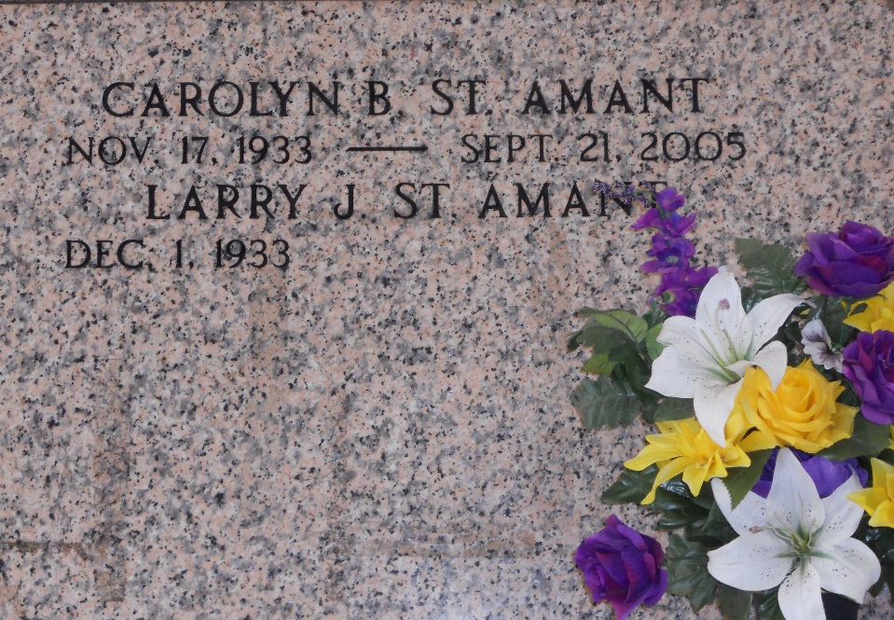
Photo by Team T-Lo

Lawrence John “Larry” St. Amant, 86, of Reserve, LA passed away on Monday, December 2, 2019 at Ochsner Hospital in Kenner. He was born on December 1, 1933 in Norco, LA to the late Lawrence and Velma St. Amant.
Larry served in the Army during the Korean War. He also played professional baseball for the Cleveland Indians. He then was employed by Shell as a lab tech, then GATX as an operator in the Barrel House and finally retired from Marathon Garyville as a Lab Tech.
Larry was a lover of all sports, especially LSU and Riverside Academy football and girls softball. He played recreational ball for the Evangeline League and the Shell Oilers. His biggest legacy was starting the Pink Potato in Norco in the late 60’s and early 70’s. He and his wife Carolyn created a safe and fun environment for the teens in the River Parishes, people still reminisce of those bygone days.
He is survived by his brothers, Lou St. Amant (Marilyn) and Erick St. Amant (Pat); his companion, Leda Mae Steib; sons, Mark St. Amant (Shelly), Kevin St. Amant , Craig “Prof” St. Amant (Jimmy Berndt) and Kent St. Amant (Donnell); grandchildren, Courtney Poche’ (Wess), Cassie Brisset (Larry), Cara Skinner (Justin), Brittney St. Amant, Taylor St. Amant and Ambree St. Amant; and great-grandchildren, Alex, Garret and Brock Brisset, Clay Skinner, Parker St. Amant and Peyton Sanders. He is preceded in death by his beloved wife, Carolyn Boutwell St. Amant.
Relatives and friends are invited to attend the visitation at St. Peter Catholic Church, LA-44, Reserve, LA on Thursday, December 5, 2019 from 9:00 AM until funeral time. A Mass of Christian Burial will take place at 11:00 AM. Interment will follow in the church cemetery.
Rose Lynn Funeral Services, Lutcher, Louisiana

