Shelly (Bourg) St. Amant
July 31, 1958 - March 5, 2024

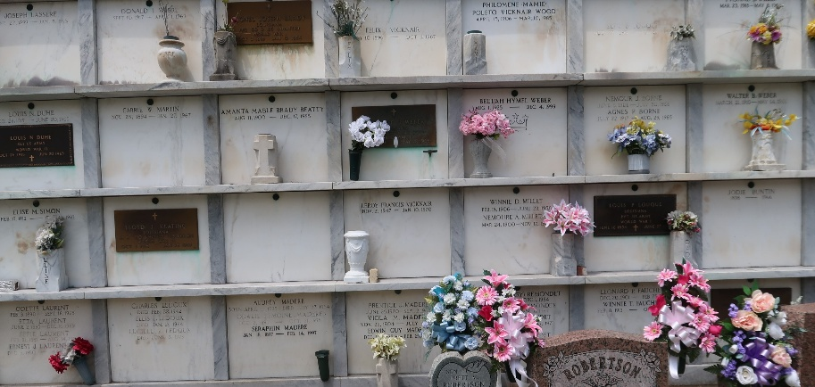

Shelly Bourg St. Amant passed away on Tuesday, March 5, 2024 at the age of 65. She was born in New Orleans, LA and a resident of Reserve, LA.
Beloved wife of Mark Joseph St. Amant. Loving mother of Courtney S. Poche (Wess), Cassie S. Brisset (Larry) and Cara S. Skinner (Justin). Grandmother of Alex Brisset, Garret Brisset, Brock Brisset, Clay Skinner and Jaci Skinner.
Daughter of the late Julia Vicknair Bourg and L.P. Bourg. Sister of Debra Calcagno (Tony), Stephanie Peranio (Sammy), Trudy Torres (the late Robert), Glenn Bourg (Virginia), Mikleen Louque (Jeff), Julie Cupit (Steve) and the late Kenny Bourg (Paula). Also survived by many nieces and nephews who were very dear to her.
Relatives and friends are invited to attend the Visitation and Memorial Mass at St. Peter Catholic Church, 1550 Hwy 44, Reserve on Saturday, March 16, 2024. Visitation will be held at the church from 8:30 a.m. to 11:00 a.m. followed by a Memorial Mass at 11:00 a.m. Private burial to be held at a later date.
In lieu of flowers please make a donation to Baylor St. Luke's Health www.supportstlukes.org

Rose Lynn Funeral Home, Lutcher, Louisiana
March 11, 2024

