Amelie M. St. Martin
October 12, 1881 – June 14, 1970

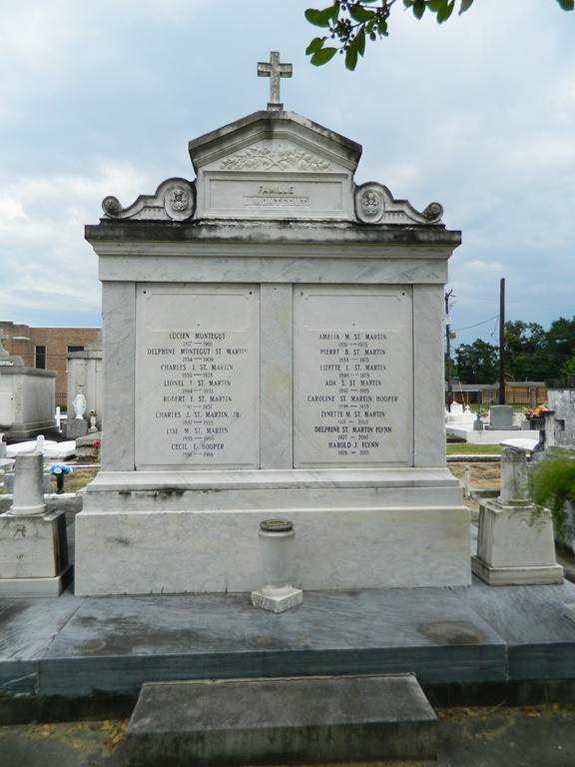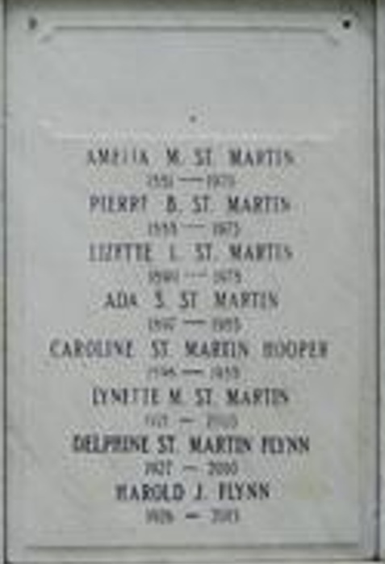

Amelie St. Martin on Sunday June 14, 1970, at 3:30 /m., sister of Peter B. St. Martin of Laplace, La., and Mrs. Caroline Hooper of Algiers, La.; daughter of the lates Charles St. Martin and Delphine Mpntegut; sister of the late Stanislaus, Charles, Robert, Lionel and Lise St. Martin; a native of Laplace, La., and a resident of Algiers, La., for the past five years.

Relatives and friends of the family are invited to attend the funeral. Services from Millet Funeral Home, Laplace, La., on Tuesday, June 16, 1970, at 8:30 o’clock a.m., religious services at St. Joan of Arc Church, Laplace, La., at 8:45 a.m. Interment in St. Peter Cemetery, Reserve, La. Visitation on Monday, June 15, 1970, after 4 p.m.
New Orleans Times-Picayune, Louisiana
July 15, 1970

