Charles J. St. Martin Jr.
March 12, 1887 – December 2, 1958

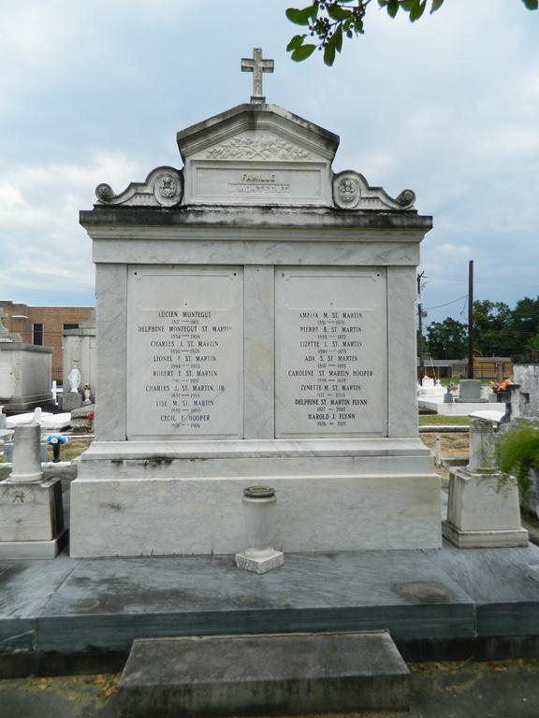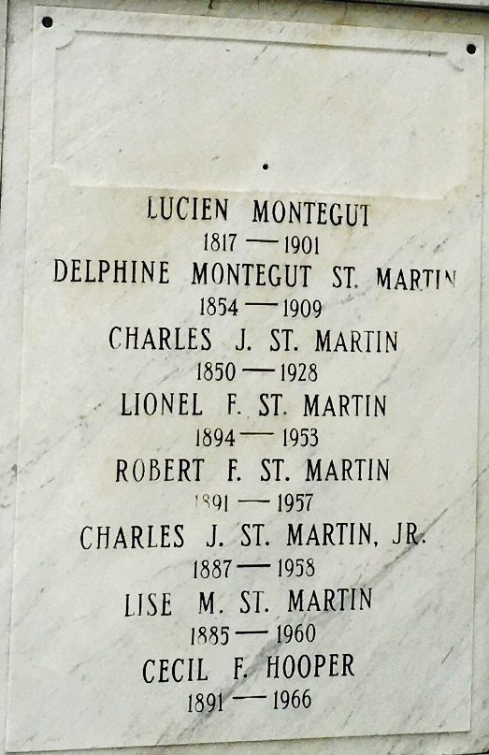

[Charles St. Martin] Age 71 years, a native and resident of Laplace, Louisiana.

Husband of the late Denise Ory and son of the late Charles St Martin and Delphine Montegut. Brother of Peter B. Sr., Lise and Amelie St. Martin and Mrs. C. F. Hooper, all of Laplace, and the late Stanislaus, Robert and Lionel St. Martin.

Services were Thursday 4 Dec 1958 at St. Peter Church, Reserve, Louisiana, with interment in St. Peter Cemetery.

The Times-Picayune, New Orleans, Louisiana
December 4, 1958

