Delphine Marguerite (Montegut) St. Martin
October 12, 1881 – June 14, 1970

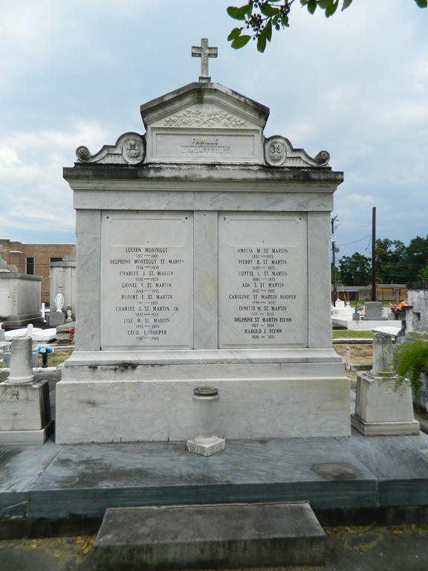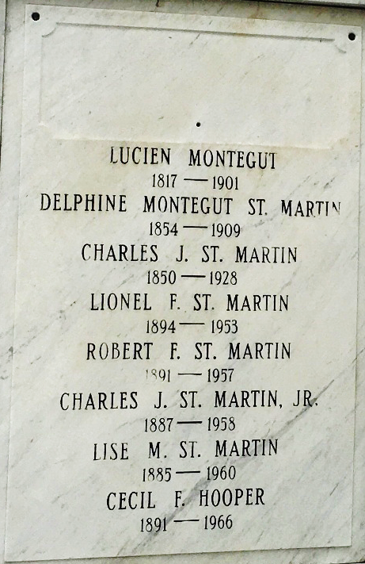

Baptized 28 Oct 1855 at St. John the Baptist Catholic Church - Edgard, La. daughter of Lucien Jean Baptiste Montégut & Amélina Adélina Haydel, baptism sponsors - Pierre Fergus Montegut & Marie Lésima Roussel, wife of Alphonse Adrien Haydel; baptized by Rev. Vito Modesto Mina, curé [SJBED-B6,389]
**

Delphine St. Martin died on Monday evening, 15 Feb 1909, on the left bank of the river at age 54 years. She was the daughter of the late Lucien Montegut and was the mother of several children. She was highly regarded and esteemed by all who knew her. Funeral services took place at St. Peter Church Wednesday, 17 Feb 1909.
Le Meschacébé, Lucy, Louisiana
20 Feb 1909

