Denise (Ory) St. Martin
July 12, 1887 – March 5, 1950

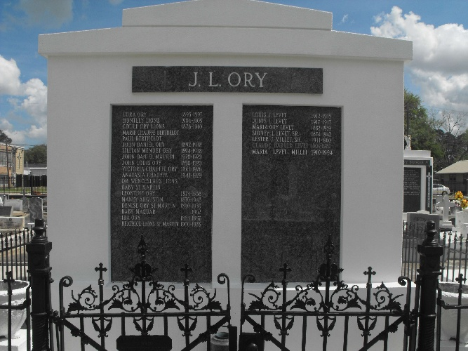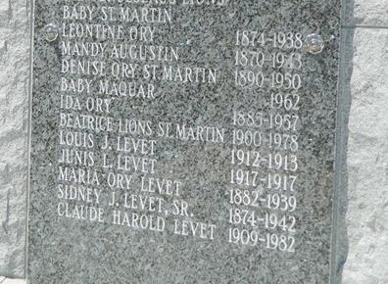

ST. MARTIN - In Laplace, La, on Sunday, March 5, 1950, at 5 o'clock a.m., DENISE ORY, beloved wife of Charles St. Martin Jr. and sister of Mrs. Henry C. Maurin of Laplace, La, and Miss Ida Ory of Lions, La, aged 62 years.

Relatives and friends of the family are invited to attend the funeral which will take place from Millet funeral home, Reserve, La, on Monday, March 6, 1950, at 9 o'clock a.m., followed by mass at St Peter's church, Reserve, La. Interment in St Peter's cemetery.

The Times-Picayune, New Orleans, Louisiana
March 6, 1950, p. 2

