Lionel Francois St. Martin Sr.
November 30, 1894 – July 22, 1953

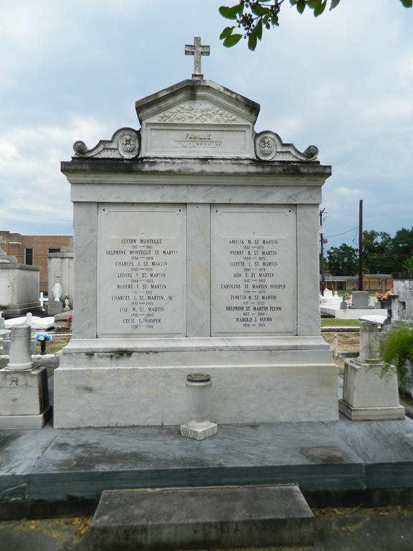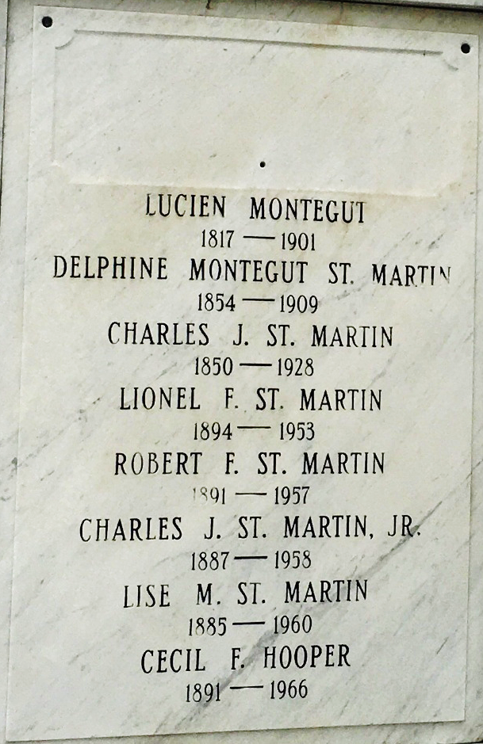

[Lionel F. St. Martin] Age 58 years, a native and resident of Laplace, Louisiana.
Husband of Ada Soileau and father of Mrs. Wanda Ollar, Mrs. Peggy Epperson, Mrs. Janice Hargroder, Lionel F. Jr., Billy, Dale and Thomas St. Martin.
Services were Thursday 23 Jul 1953 at St Peter Church, Reserve, Louisiana, with interment in St Peter Cemetery.

The Times-Picayune, New Orleans, Louisiana
July 23, 1953

