Lise Marguerite St. Martin
July 14, 1885 – February 8, 1961

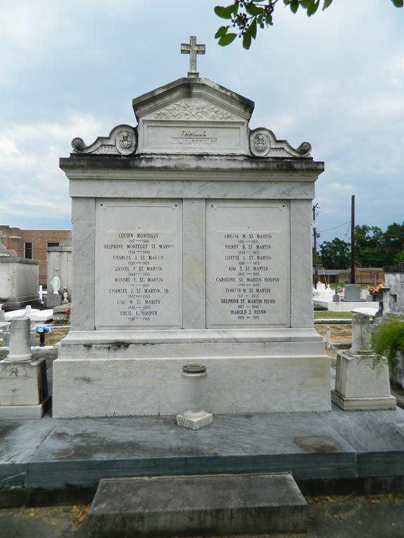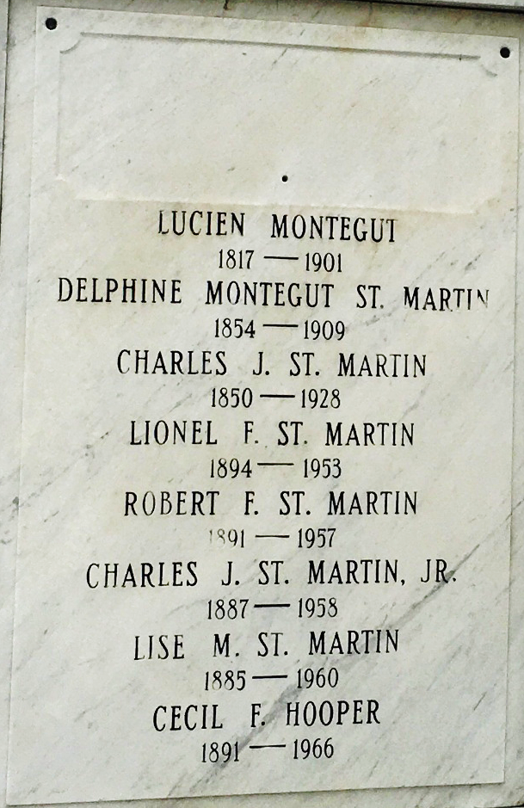

ST. MARTIN – On Wednesday, February 8, 1961, at 3 o’clock p.m. Lise St. Martin, beloved daughter of the late Charles St. Martin and Delphine Montequt, sister of Peter B. and Amelia St. Martin and Mrs. Cecil Hooper, all of Laplace, La., and the late Charles, Robert, Lionel and Stanislaus St. Martin; a native and a resident of Laplace.
Relatives and friends of the family are invited to attend the funeral. Services from the residence, Laplace, La., Thursday, February 9, 1961 at 10 o’clock a.m. Religious services at St. Joan of Arch Church, Laplace, La. Interment in St. Peter cemetery, Reserve, La.
Millet funeral home in charge.

The New Orleans States-Item, Louisiana
February 8, 1961

