Lloyd Joseph St. Martin Jr.
August 16, 1948 – March 18, 2025

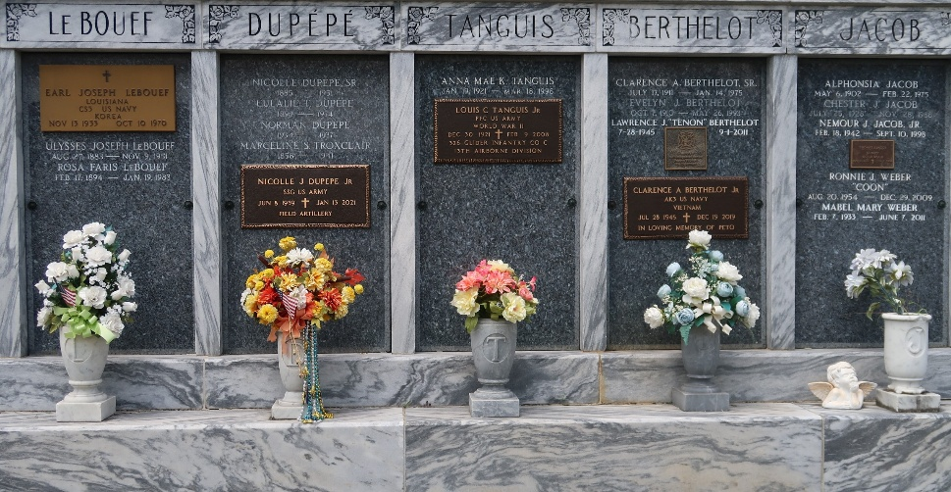

Lloyd “L.J.” Joseph St. Martin Jr. 76, of LaPlace, LA passed away peacefully on March 18, 2025, at his home while surrounded by his loving family.
L.J. was born on August 16, 1948 in LaPlace, LA. He was the son of the late Lloyd Joseph St. Martin Sr. and Francis Ockman St. Martin of Vacherie, LA.
L.J. married his high school sweetheart, Laura Remondet St. Martin, on August 3, 1968. They have been married for nearly 57 years and lived in the home he built over 50 years ago.
L.J. is survived by his three sons, Travis (Leah), Terrill (Keri), and Todd (Jessica); grandchildren, Nicole (James), Lindsey (Brett), Chelsea, Ryan, and Victoria; two great grandchildren, Timothy and Amelia, who brought so much joy and love to his life; siblings, Linda (Don) Hume, Dave (Michelle) St. Martin, and Robin (Mike) Jennings, as well as many other family members and friends. He is preceded in death by his brother, Richard (Della) St. Martin.
L.J. retired from Valero Energy Corporation where he was an Oil Movements supervisor in the operations department. L.J. was considered a “Jack of all trades”. He enjoyed working with his hands, building custom furniture, and welding. He especially loved hunting, drag racing, traveling, and riding around his neighborhood in his golf cart.
He will forever be remembered for his sense of humor, love of his family, sitting under his carport drinking beer with his friends, and aggravating his lovely and patient wife. He will be sadly missed by all who knew him. A private memorial service will be held at his residence at a later date.

Neptune Society, Kenner, Louisiana

