Allen Joseph St. Pierre Sr.
February 6, 1930 – February 28, 2025

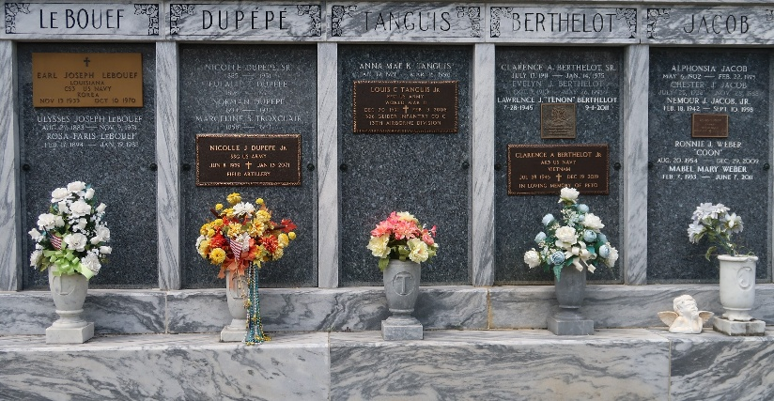

A beloved husband, father, father-in-law, grandfather, great-grandfather, great-great-grandfather, brother, uncle and friend, Allen Joseph St. Pierre Sr. passed on to our heavenly father on Friday, February 28, 2025 at the age of 95. He was born in Paulina, LA and was a long-time resident of Garyville, LA, where he spent his life caring for his family and friends and the community he called home.
He graduated from Leon Godchaux High School in 1948 where he excelled on the basketball court. Early in life he was a skilled carpenter by trade while working with his father. After being drafted in 1951 at the age of 21, he served his country with honor in the United States Army during the Korean War from May, 1951 through April, 1953. He started as a construction supervisor and left ranked Corporal. Upon completing his military service, he met and later married Audrey Millet in 1954.
Allen worked at Shell Oil Refinery in Norco as a welder and retired in 1987 after 33 and a half years while also serving during some of that time as the Union President. He was a very active volunteer in Garyville and other areas of St. John the Baptist Parish. He was elected to the St. John the Baptist Parish Council in 1984 and served many years. He was widely well respected for his integrity, knowledge, expertise, dedication and warm interactions. He served on the Board of Commissioners of the Pontchartrain Levee District from December, 2008 through December, 2024 representing the residents of St John the Baptist Parish and surrounding parishes.
Allen was a dedicated and longtime active parishioner and volunteer of St. Hubert Catholic Church where he received the Order of St. Louis Medallion on May 6, 2018 in recognition of his leadership and dedicated service to the church, the parish and throughout the Archdiocese of New Orleans. He is a member of the American Legion Louisiana Post 0383 serving 37 continuous years, an Honorary member of the Knights of Columbus, a Life Member of the Korean War Veterans Association, a Past Commanders Club Supporter of the Veterans of Foreign Wars and a Life Member of the Veterans of Foreign Wars since January, 1962, having represented Garyville Post 8167, Lutcher Post 5852 and a Member-at-Large for Louisiana.
Allen was steadfastly and fiercely supportive of his fellow citizens during all of his many duties and responsibilities in his various roles, and he was a beloved figure in the community. His greatest passions in life were his family, friends, cooking, dancing and gardening. He loved mowing his lawn and working in his yard so much that he had the most manicured yard in town. He never met a stranger and had more friends than you can imagine.
Allen was the last surviving child of the late Clement Joseph St. Pierre and Maria St. Cyr St. Pierre. He was also preceded in death by his loving wife of 61 beautiful years, Audrey Millet St. Pierre; son, Darren St. Pierre; great-granddaughter, Macilynn Clement; brothers, Earl, Lois, Elzey, Wallace and Leroy St. Pierre; sister, Dolores St. Pierre James and numerous nieces and nephews. He is survived by his daughters Darlene Vest, Kathleen (Randy) Clement and Suzanne (Joseph) Quinlan, son, Allen “A.J.” (Coy) St. Pierre, Jr., his grandchildren, step-grandchildren, great-grandchildren and step-great-grandchildren who affectionately call him “PawPaw Allen” and many nieces and nephews.
Of all of Allen’s many wonderful personal qualities, one of his greatest attributes was his love and meticulous care for his family. His children and grandchildren were of extreme importance to him, and he never wavered at the opportunity to help each of them. He was a man of integrity, strong faith in God and he had a huge heart. He will be sorely missed by his family and friends, and his legacy of compassion, leadership and love will live on in the hearts of all who had the privilege of knowing him.
Family and friends are warmly invited to gather on Thursday, March 6, 2025 at St. Hubert Catholic Church, 176 Anthony Monica St., Garyville, LA, to honor and celebrate a life well lived. Visitation will be held at the church from 11:00 a.m. to 2:00 p.m. followed by a Mass of Christian Burial at 2:00 p.m. Interment will follow at St. Peter's Cemetery in Reserve, LA.
Pallbearers are Allen St Pierre, Jr., Joseph Quinlan, Jr., Randy Clement, Jr., Jamie Clement, Dustin Clement, Dylan Clement, Parysh Vest and Paetyn Roddy. Honorary pallbearers are Randy Clement, Sr., L. J. St. Pierre, Jr., Devon Clement and Wayne Mollere.
The family would like to express their heartfelt appreciation to the staff at The Pearl at Jamestown and The Hospice of Baton Rouge for their loving care and assistance.
Millet-Guidry Funeral Home, LaPlace, Louisiana

