Charles St. Pierre Jr.
October 4, 1924 – August 20, 2005

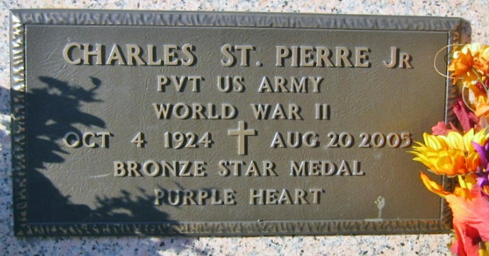
Photo by Bobby

Charles "June" St. Pierre Jr., of Mount Airy, died Saturday, Aug. 20, 2005. He was the beloved husband of 58 years to Scolastie "Catie" St. Pierre; father of Brian St. Pierre; grandfather of Tasha St. Pierre; and brother of Frank St. Pierre, LaPlace, Edna St. Pierre, New Sarpy, Emelda Louque, Paulina, Irene Dixon, St. Amant, and Velma Musso, Gramercy.
He was preceded in death by his parents, Charles Jr. and Edwige Roussel St. Pierre; and sisters, Enola St. Pierre, Delta Louque and Mercedes Louque.
He was a World War II veteran and retired from Nalco Chemicals in Mount Airy. He will be sadly missed by family, friends and granddogs, Reggie and Precious.
Visitation at H.C. Alexander Funeral Home, Lutcher, on Tuesday, Aug. 23, from 6 p.m. to 10 p.m. and on Wednesday, Aug. 24, from 8 a.m. to 9:15 a.m. Mass of Christian Burial at St. Hubert Catholic Church, Garyville, on Wednesday at 10 a.m. Entombment in St. Peter's Catholic Church Mausoleum.
The Advocate, Baton Rouge, Louisiana
August 23, 2005

