Darren P. St. Pierre
November 24, 1969 – October 5, 2005

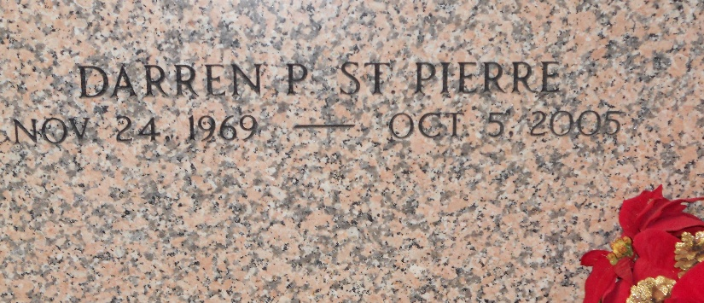
Photo by Team T-Lo

Darren P. St. Pierre on Wednesday, October 5, 2005 at 7:15 PM. Beloved husband of Christa Roccaforte St. Pierre. Father of Brooke St. Pierre. Son of Allen and Audrey Millet St. Pierre. Brother of Darlene Vest, Kathleen Clement, Suzanne Quinlan and Allen St. Pierre, Jr. Son-in-law of Lonnie and Janice Roccaforte. Brother-in-law of Scott and Randy Roccaforte, Randy Clement, Joseph Quinlan, and Coy St. Pierre. Age 35 years. A native and resident of Garyville LA. Relatives and friends of the family also members of the Monseigneur Eyraud Knights of Columbus are invited to attend services; visitation at Millet-Guidry Funeral Home, 2806 West Airline Hwy, La Place LA. On Friday, October 7, 2005 from 5:00 PM to 10:00 PM and on Saturday from 8:00 AM to 9:30 AM. followed by religious services at St. Hubert Catholic Church, 10:00 AM. Burial in St. Peter Cemetery, Reserve LA

The Times-Picayune, New Orleans, Louisiana
Oct. 8, 2005

**
Son of St. John councilman dies in two-truck accident

GARYVILLE — A fatal crash in Garyville claimed the life of 35-year old Garyville resident, Darren P. St. Pierre Wednesday afternoon.
A 2000 International Tractor pulling a waste water trailer was traveling west bound on LA 54. The driver, Steven A. Guidry Jr., 43 of Cut Off, slowed down while starting to turn left to go toward the Garyville Waste Water Plant.
St. Pierre was driving a 2001 Chevrolet Truck, also traveling west bound on LA 54, approaching the tractor trailer from behind. St. Pierre at the time did not realize the tractor trailer had slowed down to make the turn, and struck the rear end of the tractor trailer without any braking, according to Louisiana State Police TFC Omar Landrum of Troop B.

L’Observateur, LaPlace, Louisiana
Monday, October 10, 2005

