Merlene (Weber) St. Pierre
November 24, 1969 – October 5, 2005

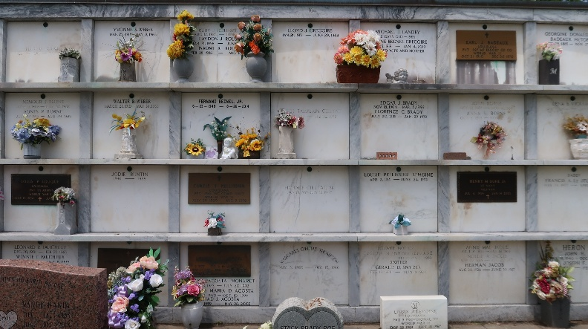

Merlene Weber St. Pierre, a native of Norco, LA and a resident of LaPlace, LA passed away on January 10th, 2020. She was 83.
She is survived by her sons, Dale St. Pierre (Susan) and Kevin St. Pierre (Lenora); her loving sister, Deanna Weber Maus. Merlene is also survived by four Granddaughters, Shelbi, Sara, Peyton and Ashlyn St. Pierre and numerous nieces and nephews.
Merlene is preceded in death by her husband, Frank St. Pierre; Father and Mother, Peran and Clementine Weber; brothers, Perrin, Marlvain “Tojo” and Glynn Weber. She is also preceded in death by one sister, Margaret Catoire Laurent.
Merlene was Class of 1954 Valedictorian at Destrehan High School. She loved to cook and enjoyed dancing with her husband Frank. She also loved sitting for and spending time with her grandchildren.
Visitation will be on Wednesday, January 15th, 2020 from 9:00am until 11:00am at Ascension of Our Lord Catholic Church in LaPlace, LA. A Mass of Christian Burial will take place at 11:00am with burial following in St. Peter Catholic Cemetery in Reserve, LA.
In lieu of flowers, the family requests donations for Masses at Ascension of Our Lord Catholic Church in LaPlace, LA.

Rose Lynn Funeral Home, Lutcher, Louisiana

