Scolastie T. (Ory) St. Pierre
October 1, 1922 – February 9, 2025

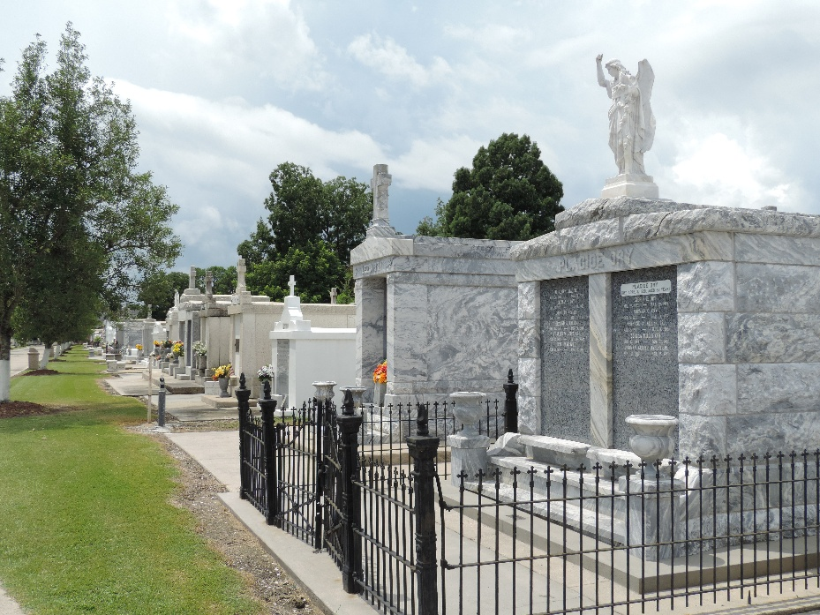

Scolastie Ory St. Pierre (Catie) passed away on Sunday, February 9, 2025 at the age of 102. Catie was the beloved wife of the late Charles St. Pierre, mother of Brian and grandmother of Tasha Raphile.
Born in Mt. Airy on October 1, 1922, Catie lived her entire life on the same property along the River Road. She was the last surviving child of Emilien Ory, Jr. and Louisa Vicknair Ory. Her siblings, Earline Babin, Eva Gayaut, Mable Ory, Raymond Ory, Ida Smith, Genevive Lemoine and Ernestine Ory were born and also raised there. Catie is survived by numerous nieces and nephews.
Catie never left S. John Parish, working for over 40 years in the office of Godchaux Sugar.
Relatives and friends are invited to attend the Visitation and Funeral Mass on Wednesday, February 19, 2025 at St. Peter Catholic Church, 1550 LA-44, Reserve, LA 70084. Visitation from 10:00 a.m. – 11:00 a.m., with a Funeral Mass to follow at 11:00 a.m.

Millet-Guidry Funeral Home, LaPlace, Louisiana

