James A. Starkes

July 15, 1918 – January 24, 2008

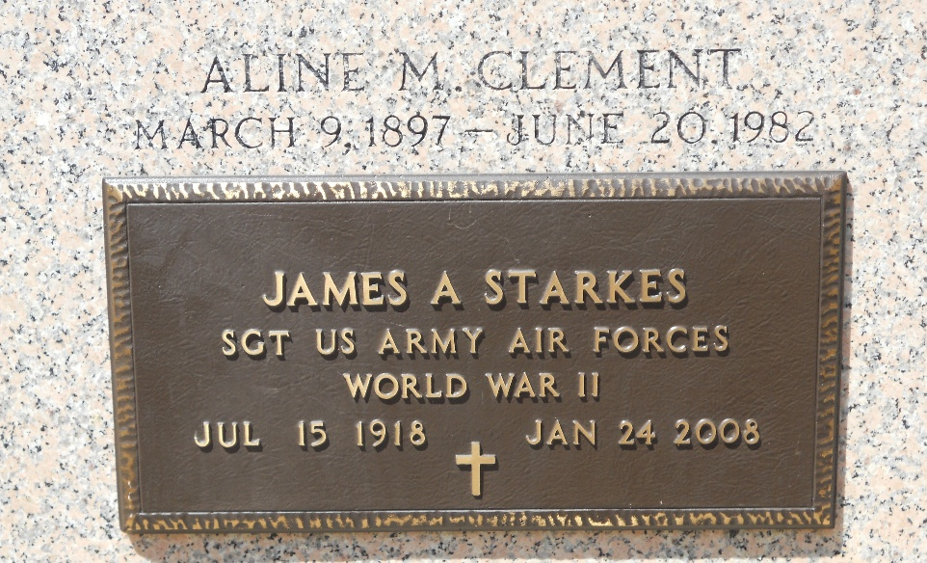
Photo by Team T-Lo

James A. Starkes on Thursday, January 24, 2008.

Beloved husband of Lilly Clement Starkes. Son of the late John and Lillian Starkes. Brother of Marjorie Shultz, Lillian Clark, Frank Starkes, the late John Starkes and Gladys Haight. Brother-in-law of Juliette Alford, Daniel Clement, Helen Satterlee, Melba Catoire, Gerald Clement, Carmen Weber, Elizabeth Cehlar, the late Nina Scalco, William Clement, Jr. and Roy Clement.
Age 89 years. A native of New York and a resident of Metairie, LA for the past 60 years.

Unknown source

