Lillian (Scioneaux) Starlone
August 1, 1934 – March 1, 2007

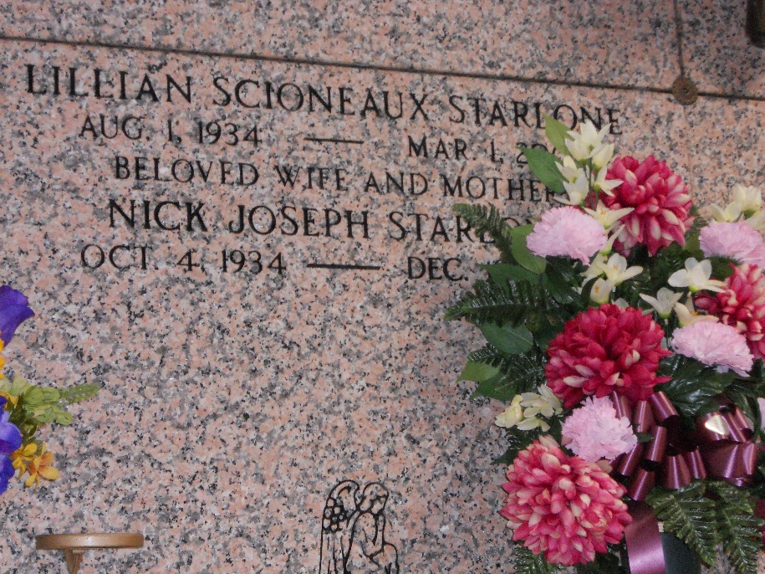
Photo by Team T-Lo

Lillian Scioneaux Starlone on Thursday, March 1, 2007. Age 72, a native of Reserve, LA and a resident of Metairie, LA for the past 45 years.
Beloved wife of Nick Starlone. Mother of Marsha S. Bianchini and Debra S. Grumbach. Daughter of the late Laura Borne and Ursin Scioneaux. Sister of Lorraine Loupe, Doris Savoie, and the late Irvin Scioneaux. Grandmother of Nicholas, Matthew, and Peyton Bianchini and Elizabeth and Laura Grumbach. Aunt of Karen, Warren Jr., Mark, Irvin Jr., Todd, Bart, Jason and Kimberly.
Relatives and friends of the family are invited to attend the funeral. Services from the Kenner Funeral Home of L. A. Muhleisen and Son, 2607 Williams Blvd. on Monday, March 5, 2007 at 11:00 o'clock a.m. followed by a Funeral Mass at Our Lady of Divine Providence Catholic Church, 1000 N. Starrett Rd., Metairie. Visitation at the Funeral Home from 9:00 a.m. until 11:00 a.m. on Monday. Interment in St. Peter Catholic Cemetery, Reserve, LA.

The Times-Picayune, New Orleans, Louisiana
March 4, 2007

