Joseph Leo Steib
December 28, 1927 – December 16, 2000

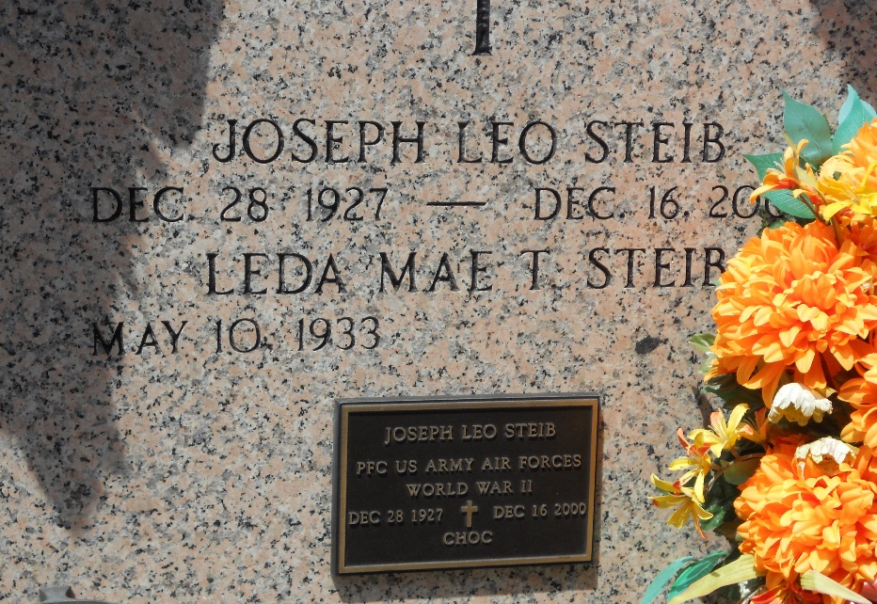
Photo by Team T-Lo

Joseph Leo "Choc-a-let" Steib, 72, a native of Vacherie and resident of Reserve, died Dec. 16. He was the husband of Leda Mae Trosclair Steib and father of Kelly Kliebert and Robert "Rusty Bean" Steib. He was also the son of the late Henry and Octavie Tregre Steib, brother of the late Robert and Leroy Steib, and stepbrother of the late Lois and Daniel Borne. He is also survived by four grandchildren. Services were held Dec. 19 at St. Peter Catholic Church, Reserve, with interment at the church cemetery.
L'Observateur, LaPlace, Louisana
December 20, 2000

