Andrews Stein Jr.
June 20, 1912 – December 2, 1987

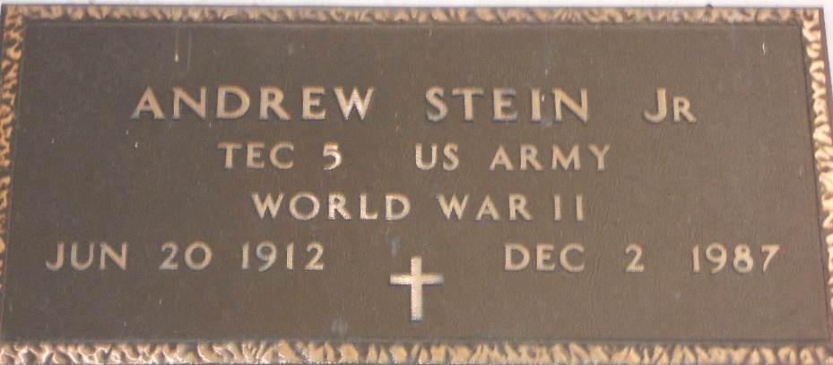
Photo by Team T-Lo

Andrew (Bum) Stein on Wednesday, December 2, 1987 at 10:30 a.m.

Beloved husband of Annabel Millet Stein. Brother of Vince Stein of Laplace, La, Lawrence (Corky) Stein of Norco, La, and the late Harry Stein. Uncle of Jeanne Gregoire of Garyville, La. Son of the late Andrew Stein Sr and Correstile Weber. Age 75 years. A native of Vacherie, La. and a resident of Laplace, La for the past 48 years.

Relatives and friends of the family are invited to attend the Funeral service at GUIDRY MEMORIAL FUNERAL HOME, 2806 West Airline Highway, Laplace, La, on Friday, December 4, 1987 followed by a Mass of Christian Burial in the Funeral Home Chapel at 12:00 noon. Interment St Peter Cemetery, Reserve, La.

The Times-Picayune, New Orleans, Louisiana
December 3, 1987, p. B-11

