Annabel (Millet) Stein
January 10, 1918 – December 15, 2005

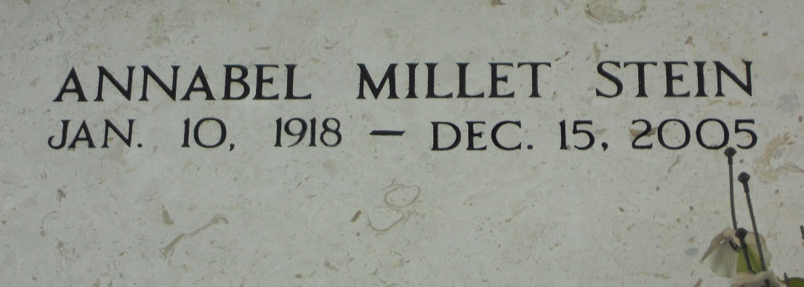
Photo by Team T-Lo

LAPLACE - Annabel Millet Stein, 87, a native and resident of LaPlace, died Dec. 15.

She was the wife of the late Andrew "Bum" Stein. She is survived by her nieces and nephews.

She was preceded in death by her parents Noe and Noelie Millet, siblings Denise M. Perilloux, Antoinette Millet, Ernest Millet, May M. Tregre Sicard, Lillian M. Mobile.

Services were held Dec. 19 at Millet-Guidry Funeral Home Chapel, LaPlace, with interment in St. Peter Cemetery, Reserve.

L’Observateur, LaPlace, Louisiana
Thursday, December 22, 2005

