Archange (Hebert) Stein
February 27, 1896 – August 20, 1985

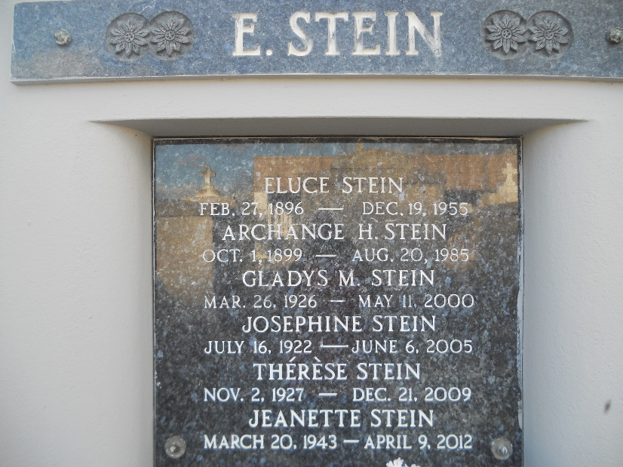
Photo by Team T-Lo

Archange H. Stein on Tuesday, August 20, 1985 at 4:20 a.m. Beloved wife of the late Eluce Stein. Mother of Josephine, Gladys, Teresa, Mary Ann, Jennette, Norris, Joseph, Alvin, Paul and Nelson Stine, Mrs. Clifton (Lena) Vicknair and Mrs. Joseph (Ruby) McClean also the late Ulysse and James Stein. Daughter of the late Mr. and Mrs. Ramy Hebert. Also survived by 32 grandchildren and 32 great-grandchildren. Age 85, a native of Vacherie, La. and resident of Reserve for the past 55 years.

Relatives and friends of the family are invited to attend the funeral services from Millet Funeral Home, Reserve, La. on Thursday, August 22, 1985. Followed by religious services at St. Peter Catholic Church at 10 a.m. Interment in Church Cemetery. Friends may call from 5 to 10 p.m. on Wednesday, August 21, 1985 and from 8 a.m. until services on Thursday.

The Times-Picayune, New Orleans, Louisiana
Wednesday, August 21, 1985, p. A-31, c. 6

