Carmen (Montegut) Stein
June 27, 1915 – February 23, 2005

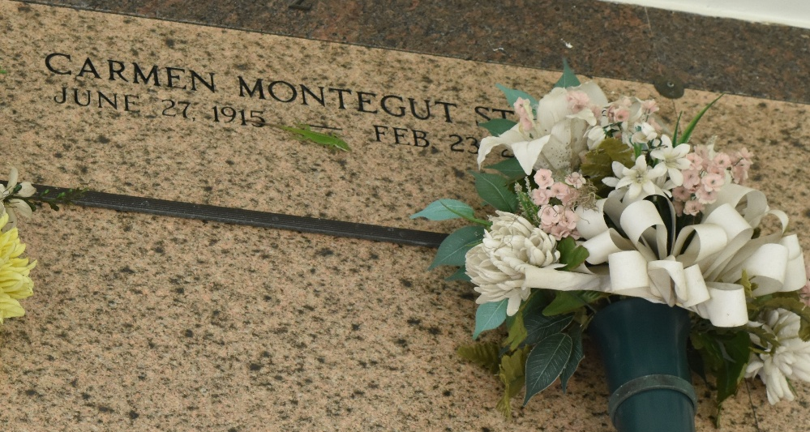

Carmen Montegut Stein on Wednesday, February 23, 2005 at 11:50 A.M.
Beloved wife of the late Vince J. Stein. Daughter of the late James and Denise LeBrun Montegut, Sr. Sister of the late Claire Madere, Olga Rodrique, Jeanne, Harold, Marcel, Sidney and James Montegut, Jr. Survived by numerous nieces, nephews, and other relatives.
She was a member of the Ladies Altar Society. Age 89 years. A native and lifelong resident of Laplace, LA.
Relatives and friends of the family are invited to attend services. Visitation at St. Joan of Arc Catholic Church, Laplace, LA on Friday, February 25, 2005 from 10:00 A.M until 12:00 P.M. followed by a Mass of Christian Burial at 12:00 Noon. Burial in St. Peter Church Cemetery, Reserve, LA. Arrangements by MILLET-GUIDRY FUNERAL HOME, Laplace, LA.

The Times-Picayune, New Orleans, Louisiana
February 24, 2005

