Gladys M. Stein
March 26, 1926 – May 11, 2000

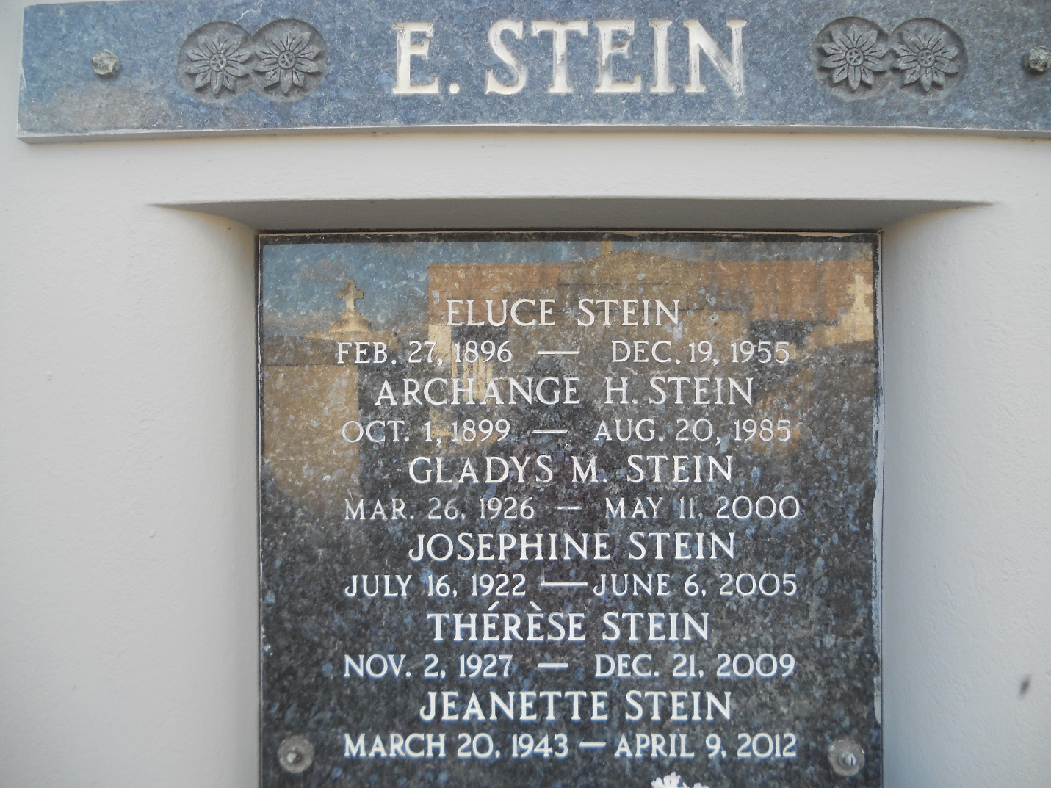
Photo by Team T-Lo

Gladys Stein, 74, a native and resident of Reserve, died May 11.

She was the daughter of the late Eluce and Archange Stein and sister of Norris, Joseph, Paul, Nelson, Alvin, Josephine, Theresa, Mary Ann and Jeanette Stein, Ruby McClean and the late Lena Vicknair and Ulysses and John Stein.

Services were May 12 at Millet-Guidry Funeral Home, Reserve, with interment at St. Peter Cemetery, Reserve.
L'Observateur, LaPlace, Louisiana
May 13, 2000

