Joseph Stein Sr.
June 27, 1924 – October 23, 2021

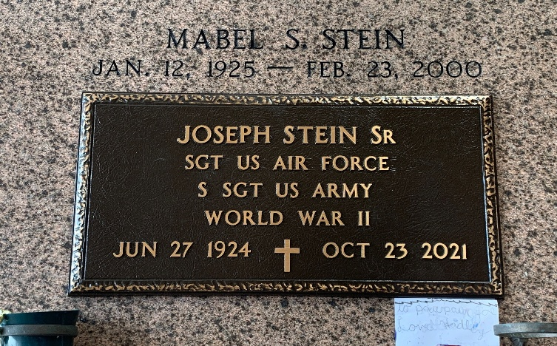
Photo by Team T-Lo

Joseph Stein, Sr. born on June 27, 1924 in Lily, Louisiana passed away peacefully at St. James Hospital in Lutcher, Louisiana on October 23, 2021 at the age of 97.
He was preceded in death by his parents, Eluce and Archange Stein; siblings, Eluce Jr., Paul, Alvin, Lena, Josephine, Gladys, Therese and Jeanette; beloved wife of 53 years, Mabel Schexnayder Stein; and grandson, Paul.
He is survived by his siblings, Norris, Nelson, Ruby and Mary Anne; sons, Michael (Jan), Joseph Jr., Kenneth (Mariela) and Gary (Becky); loving companion of 15 years, Leana Ockman and her children; grandchildren, Jason, Jessica, Rhonda, Paula, Carrie, Adam, Kristie, Justin, Jennifer, Brandon, Jesse, Christi, Amy, and Patrick; and 27 great grandchildren who all called him PaPa Joe.
This proud veteran of World War II served in both the Army and the Army Air Force. He was always willing to help a friend or relative in need.
The family would like to thank the staff of St. James Parish Hospital for their care and hospitality.
Relatives and friends are invited to attend services. Visitation will be held at St. Hubert's Roman Catholic Church, 176 Anthony F Monica St., Garyville, Louisiana on Thursday, October 28, 2021 from 9:00 a.m. to 11:00 a.m. followed by a Funeral Mass at 11:00 a.m. Burial will follow at St. Peter Catholic Cemetery in Reserve, Louisiana.
Millet-Guidry Funeral Home, LaPlace, Louisiana
October 27, 2021

