Josephine Stein
July 16, 1922 – June 6, 2005

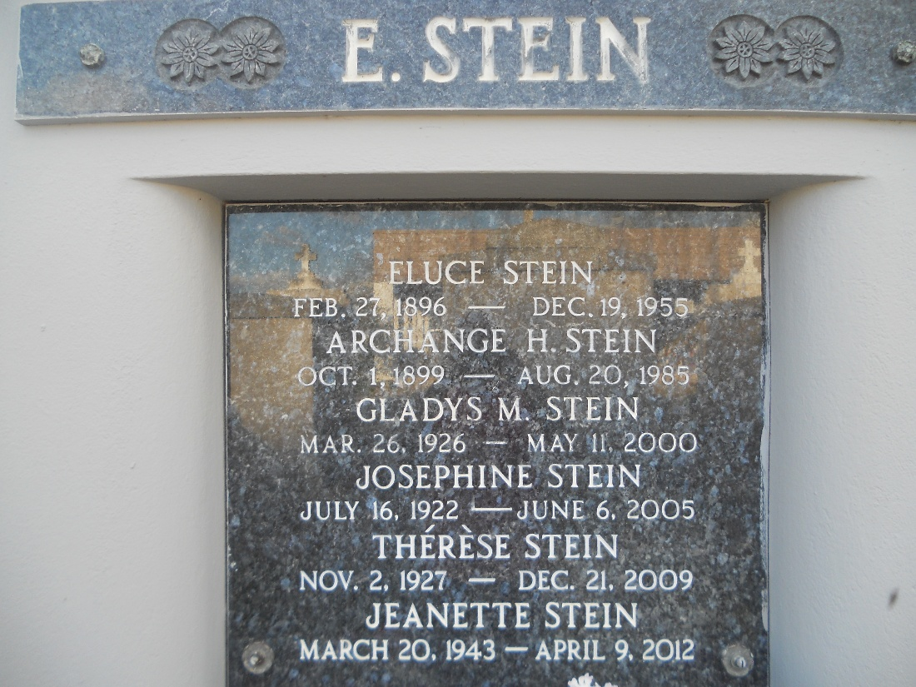
Photo by Team T-Lo

Josephine Stein, on Monday, June 6, 2005, at 12:15 P.M.

Beloved daughter of the late Eluce and Archange Hebert Stein. Sister of Norris, Joseph, Paul, Nelson, Alvin, Marie, Mary Ann, and Jeannette Stein, Ruby Mc Clain, and also the late Eluce Stein, Jr., Lena Vicknair and Gladys Stein. Also survived by nieces and nephews. Age 82. A native of Convent, LA and a resident Lions, LA for the past 77 years.

Relatives and Friends of the Family are invited to attend services. Visitation at MILLET-GUIDRY FUNERAL HOME, 2806 W. Airline Hwy., Laplace, LA, on Thursday, June 9, 2005, from 9 A.M to 10 A.M. Followed by Religious Services at the Funeral Home Chapel at 10 A.M. Burial in St. Peter Cemetery, Reserve, LA.
The Times-Picayune, New Orleans, Louisiana
June 8, 2005

