Loretta (Folse) Stein
September 18, 1940 - March 15, 2026

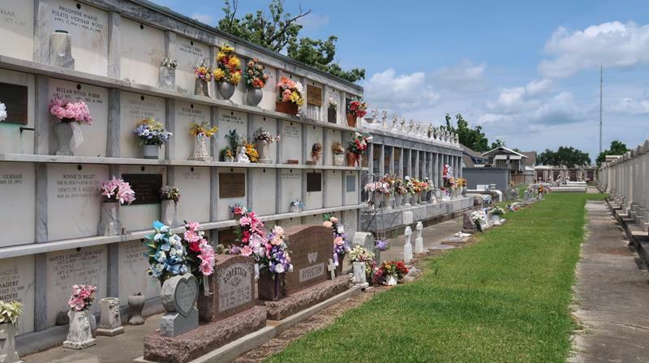

Loretta Folse Stein passed away on Sunday March 15, 2026 at the age of 85.
Beloved wife of James Stein for 63 years. Loving mother of Theron “Tee” Stein (Lisa), Scotty Stein (Julie). Grandmother of Joshua Stein , Jacques Stein (Hailey), Victoria Laiche (Kolby), Kelsie Puccio (Dylan), and Jacob Stein (Paige). Great-grandmother of Talon Stein, Wyatt Puccio, Rynn Puccio, Lucas Puccio, Taytum Stein, Veida Stein, Valen Laiche, and Kip Laiche.
Daughter of the late Charles “Charlie” Folse and Louella “Toon” Anderman Folse. Sister of the late Charlene Pollet (Dr. Dale). Aunt of Nikki Pollet and Shannon Pollet (Christine). Godmother of Nikki Pollet and Clark Anderman. Daughter-in-Law of Justin and Sophie Stein. Also survived by numerous cousins.
Relatives and friends are invited to attend the Memorial Visitation and Memorial Mass on Friday March 20, 2026 at St. Peter Church in Reserve. Visitation from 9:00 am-11:00am followed by Memorial Mass at 11:00 am. Burial will be private.

Rose Lynn Funeral Home, Lutcher, Louisiana

