Louis Joseph Stein Sr.
April 16, 1873 – February 9, 1961

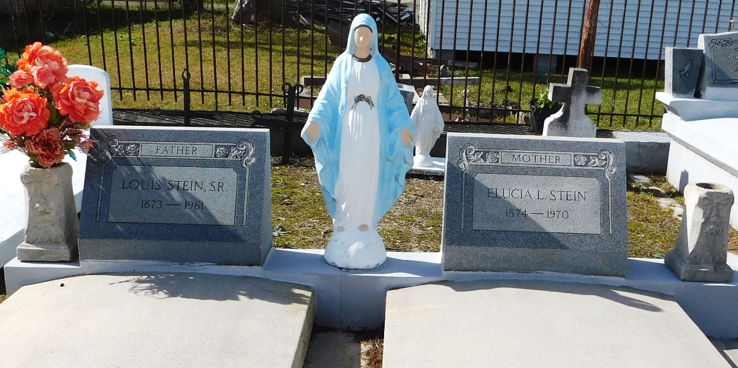
Photo by Mary Agnes Hammett

Louis Stein, Sr., 87, Resident of Reserve, Expires; Rites Held

Funeral Services for Louis Stein, Sr., 87, a resident of Reserve, were held last Friday from the Millet Funeral Home, followed by religious services at St. Peter church and interment in St. Peter cemetery.
Mr. Stein was a native of Vacherie and had resided in Reserve for the last 34 years. He expired on February 9.
Mr. Stein is survived by his widow, the former Elucia Lassere; six daughters, Mrs. Anicet Trosclair, Mrs. Anicet Trosclair, Mrs. Lionel Faucheux, Mrs. Albert Hotard, Mrs. Walter Weber, Mrs. Carl Montz and Mrs. Rodney Duhe, and two sons, Louis Stein, Jr., and Henry Stein.
He also is survived by 51 grandchildren and 71 great-grandchildren.

L’Observateur, Reserve, Louisiana
Thursday, February 16, 1961, p. 7

