Mamie Marie (Vicknair) Stein
April 5, 1956 – June 19, 2011

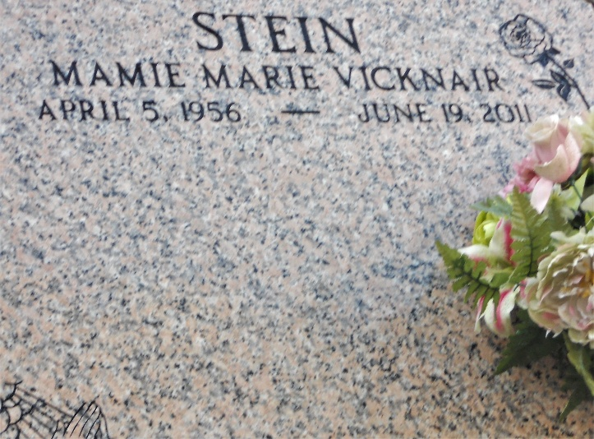
Photo by Team T-Lo

Mamie (Marie) Vicknair Stein passed away on Sunday, June 19, 2011.

Beloved wife of Norris Stein. Mother of Ricky Stein (Kimberly) and Allen Stein (Michelle). Grandmother of Brett, Ryleigh, Parker and Kooper. Daughter of Shirley Oubre and the late Alvin Vicknair Sr. Step-daughter of the late Allen Oubre. Sister of Alvin Vicknair Jr., Shirley Rodrigue and the late Paul Vicknair. Age 55. A native and resident of Reserve, LA.

Relatives and friends are invited to attend services. Visitation at Millet-Guidry Funeral Home, 2806 W. Airline Hwy., LaPlace, LA, on Tuesday, June 21, 2011 from 5:00 pm to 9:00 pm and on Wednesday from 8:00 am to 9:30 am, followed by Mass at St. Peter Catholic Church, Reserve, LA at 10:00 am. Burial in church cemetery.

The Times-Picayune, New Orleans, Louisiana
Jun. 21, 2011

