Mary Ann Stein
August 30, 1939 – December 29, 2022

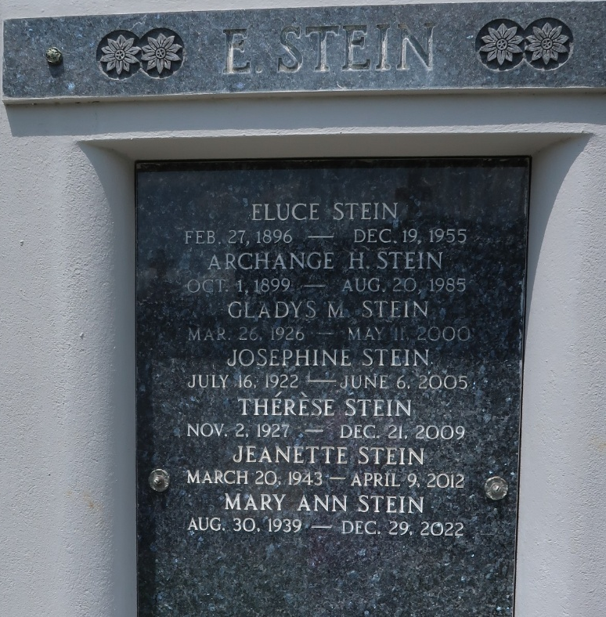

Mary Ann Stein died on Thursday, December 29, 2022 at the age of 83.

Daughter of the late Eluce and Archange Hebert Stein. Sister of Ruby McClean and Nelson Stein and the late Norris Stein, Joseph Stein, Paul Stein, Alvin Stein, Lena Vicknair, Josephine Stein, Gladys Stein, Therese Stein and Jeanette Stein. Also survived by many nieces and nephews.

Relatives and friends are invited to attend a Funeral Mass at 11:00 AM on Wednesday, January 4, 2023 at Millet-Guidry Funeral Home, 2806 W. Airline Hwy, LaPlace, LA 70068. Visitation will begin at 9:00 AM. Interment will be in St. Peter Cemetery.
Millet-Guidry Funeral Home, LaPlace, Louisiana
December 31, 2022

