Norris Joseph Stein Sr.
October 11, 1920 – May 15, 2022

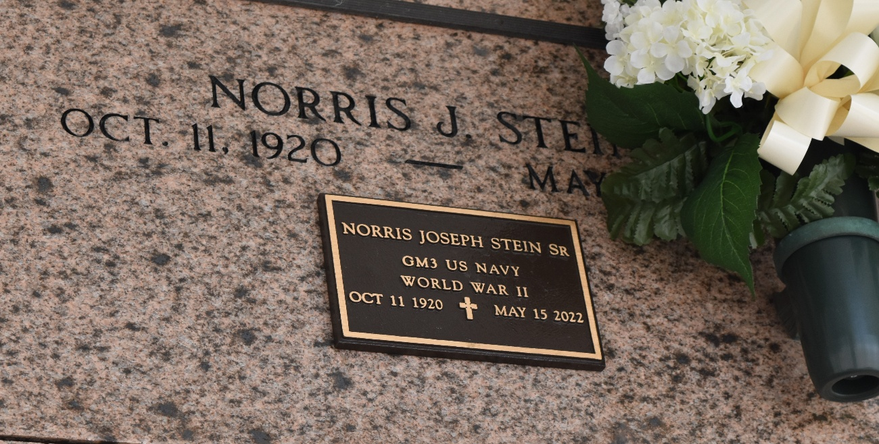

Norris Joseph Stein, Sr. passed away on Sunday, May 15, 2022 at the age of 101. He was native of Convent, LA and a resident of Reserve, LA. He proudly served his Country during WW II in the U. S. Navy.
Norris retired from Godchaux Sugar Refinery. Throughout his life up until he turned 100 he loved to Garden and shared with family and friends. He also enjoyed fishing and shrimping.
Beloved husband of the late Pauline Becnel Stein. Loving father of Barbara Stein Forsythe (Farrel), Elizabeth Stein Blank, Norris J. "Ricky" Stein, Jr. (the late Marie Stein), Jody Stein (Melanie), and the late Mark S. Stein. Grandfather of Farrel Forsythe, Jr. (Dolly), JoAnne Forsythe Gonzalez (Ruben), Terri Forsythe Koehler (Troy), Brad Blank (Tara), Matthew Blank, Ricky Stein, Allen Stein (Michelle), Chelsey Stein Dupepe (Joseph), Megan Stein Ganucheau (Garrett). Great grandfather of Ryan, Tara, Brooke, Nickolas, Loren, Morgan, Matthew Jr., Tyler, Ashton, Carley, Brett, Ryleigh, Ramsey, Kooper, Parker, Presley, Maxon, Marlee, and the late Brynlee. Great great grandfather of Isabelle, Bennett, Lucas, Knox and Olivia.
Son of the late Eluce Stein and Archangle Hebert Stein. Brother of Ruby S. McClean (the late, Joseph), Nelson Stein (the late, Norma Jean), Mary Ann Stein and the late Josephine Stein, Gladys Stein, Teresa Stein, Jennette Stein, Joseph Stein (Mable), Alvin Stein (Fern), Paul Stein (MaryAnn), Lena Stein Vicknair (Clifton), Ulyese Stein and James Stein. Also survived by many nieces and nephews.
Relatives and friends are invited to attend the Funeral. A Funeral Mass will be celebrated at St. Peter Catholic Church, 1550 Hwy 44, Reserve on Wednesday, May18, 2022 at 12:00 p.m. Visitation will be held from 10:00 a.m. to 12:00 p.m. Interment in St. Peter Cemetery, Reserve, LA.
Millet-Guidry Funeral Home, LaPlace, Louisiana
May 17, 2022

