Norwood Joseph Stein Sr.
September 29, 1924 – November 18, 2003

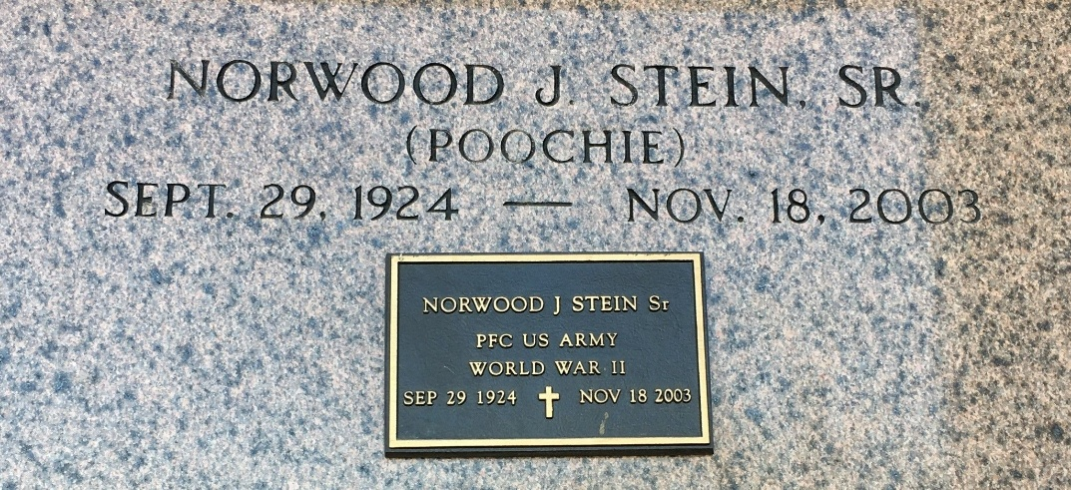
Photo by Team T-Lo

Norwood (Poochie) Stein, Sr. on Tuesday, November 18, 2003 at 9:10 PM.
Beloved husband of 55 years of Rowena Bourgeois Stein. Father and Father-in-law of Wayne and Maria Stein, Norwood (Co) Jr. and Kay Stein and Kelly and Jan Stein. Son of the late Henry and Eva Michel Stein. Brother of Houston and Henry Stein, Jr., Mae Louque, and Earline Vicknair. Grandfather of Chris, Wayne, Jr., Danny, and Timmy Stein, Sunny Waguespack, Liz Stein and the late Jeramy Stein. Great grandfather of Easton Waguespack. He was a U.S. Army Veteran of World War II. Age 79, a native of Convent, and resident of Reserve for past 65 years.
Relatives and friends of the family, also members of The Reserve American Legion and VFW are invited to attend services. Visitation at MILLET-GUIDRY FUNERAL HOME, 2806 West Airline Hwy., Laplace on Thursday, November 20, 2003 from 5 PM to 9 PM and on Friday from 8 AM to 9:45 AM followed by religious services at St. Peter Catholic Church, Reserve, LA at 10 AM. Burial in church cemetery.

The Times-Picayune, New Orleans, Louisiana
Nov. 20, 2003

