Rowena (Bourgeois) Stein
March 19, 1925 – May 26, 2010

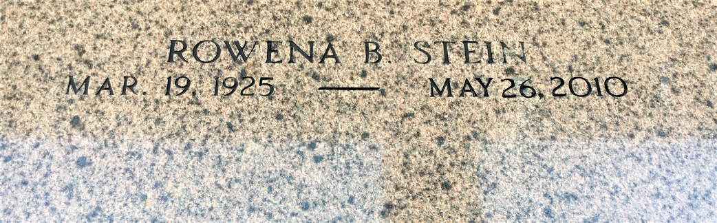
Photo by Team T-Lo

Rowena Bourgeois Stein passed away on Wednesday, May 26, 2010.
Beloved wife of the late Norwood (Poochie) Stein. Mother of Wayne and wife Maria, Norwood Jr. and wife Kay and Kelly and wife Jan Stein. Grand-mother of Chris, Danny, Timmy and Wayne Stein Jr., Sunny Waguespack, Liz Evans and the late Jeramy Stein. Great-grandmother of Easton and Anna Waguespack and Avery Evans.
Daughter of the late Ludovic and Louise Bourgeois. Sister of Marion Madere and the late Noeda Matherne, Russell and Elton Bourgeois.
Special thanks to her sitters. Age 85. A native of Grand Point, La. and a resident of Reserve.
Relatives and friends are invited to attend Services. Visitation at St. Peter Catholic Church, Reserve, La. on Friday, May 28, 2010 from 10:30 am to 12:00 noon. Followed by a Mass at 12:00 noon. Burial in St. Peter Cemetery. Arrangements by Millet-Guidry Funeral Home, LaPlace, La.

The Times-Picayune, New Orleans, Louisiana
May 27-28, 2010

