Charlene (Roussel) Stephens
October 24, 1949 – July 24, 2012

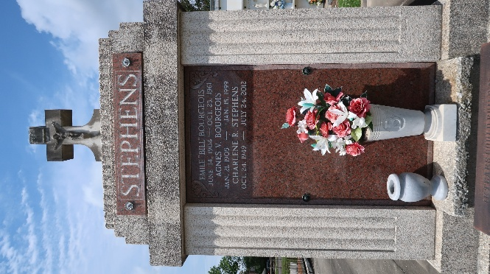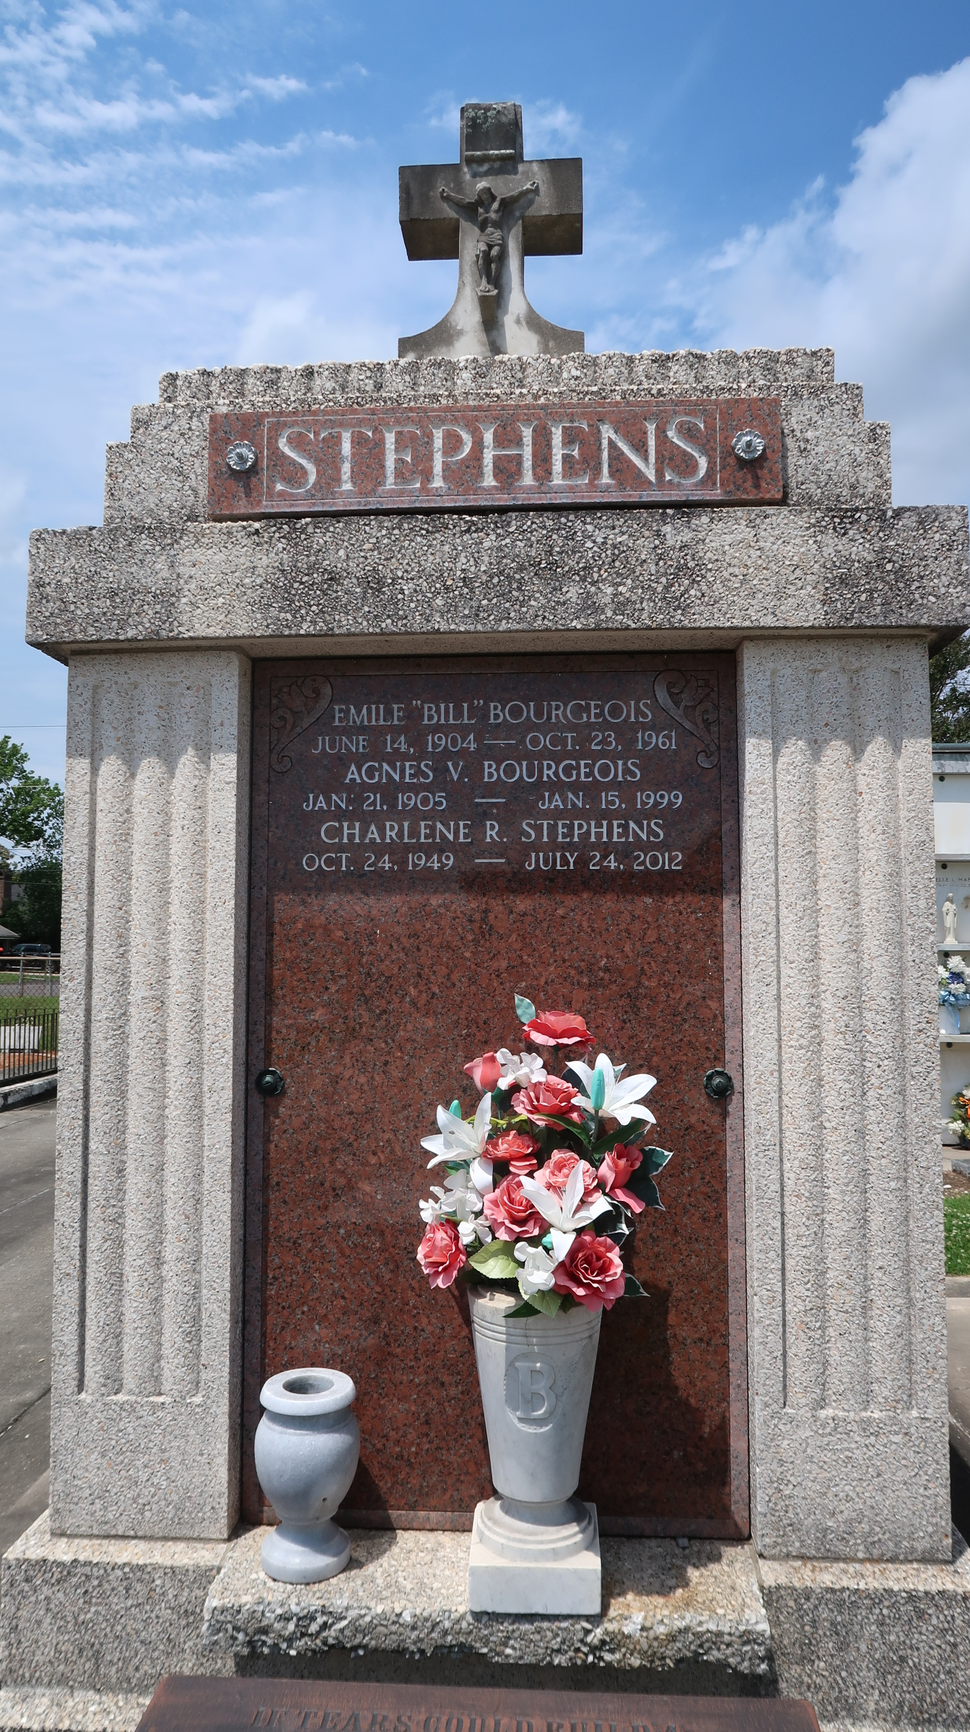

Charlene Roussel Stephens passed away on Tuesday July 24, 2012.
Beloved wife of Larry Stephens. Mother of Michael Stephens (Niki) and Lisa Judd (Travis). Grandmother of Devon, Taylor, Logan, Destiny and Dustin.
Daughter of Mae Vicknair Roussel and the late Anicet (Tom Tom) Roussel. Sister of Barry Roussel (Dodie). Age 62. A native and resident of Reserve, LA.
Relatives and friends are invited to attend services. Visitation at Millet-Guidry Funeral Home, 2806 W. Airline Hwy. LaPlace, LA on Thursday July 26, 2012 from 5:00pm to 9:00pm and on Friday from 8:00am to 9:45am, followed by Mass in The Funeral Home Chapel at 10:00am. Burial in St. Peter Cemetery, Reserve, LA.

The Times-Picayune, New Orleans, Louisiana
July 25-26, 2012

