Kathleen B. Stewart
Augus 11, 1938 – October 11, 2011

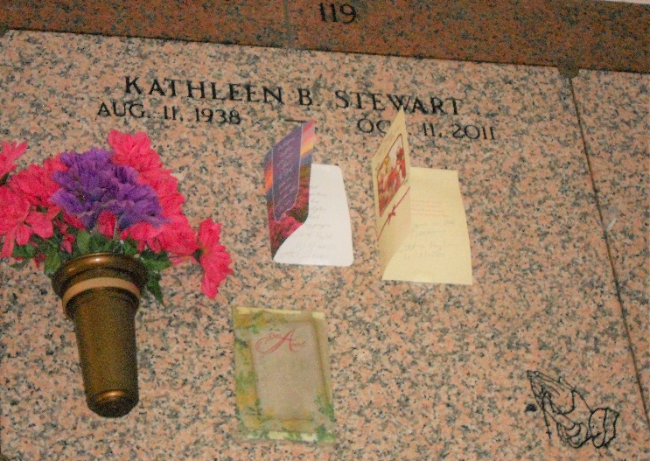
Photo by Team T-Lo

Kathleen Bonetta Stewart on Tuesday, October 11, 2011 at Ochsner Medical Center, Jefferson, LA.
Daughter of the late Louise Arceneaux and James Stewart. Sister of Ernestine Stewart and the late Beverly Williams, Bernadine Stewart, Gloria Stewart, Clancy Leo Stewart and Louis Ferrel Stewart. Also survived by a host of nieces, nephews, other relatives and friends. Age 73 years. A native and resident of Reserve, LA.
Relatives and friends of the family, also priest and parishioners of Our Lady of Grace Catholic Church and all neighboring churches, employees of Department of Health & Hospitals and St. John the Baptist Parish School System are invited to attend the Mass of Christian Burial at Our Lady of
Grace Catholic Church, 772 Highway 44, Reserve, LA, on Saturday, October 15, 2011 at 11:00 AM. Father Joseph Rodney, Celebrant. Interment: St Peter Cemetery, Reserve, LA. Visitation at the above named church from 9:00 AM until Mass time. SERVICED BY ROBOTTOM

The Times-Picayune, New Orleans, Louisiana
October 14, 2011

