Audrey (King) Sudkamp
May 26, 1922 – April 17, 2009

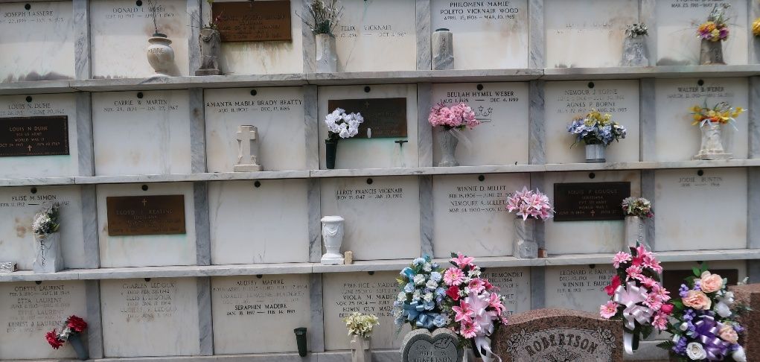

Audrey King Sudkamp died on Friday, April 17, 2009 at her residence in New Sarpy, LA at the age of 86. She was a native of Reserve, LA and a retired St. Charles Parish Public School Cafeteria Manager with over 15yrs of service.
Survived by four sons and spouses, John D. Sudkamp Jr. (Vicki), J. Charles Sudkamp (Diane), Gregory J. Sudkamp (Linda), and Stephen D. Sudkamp (Mary); three daughters and spouses, Beverly S. Monk (Tom), Rose S. Dufrene (Ronnie) and Cheryl S. Miller (Ronn); niece and godchild, Jackie A. Madere (Elmo); one sister-in-law, SR. Augustine "Cora" Sudkamp; twenty three grandchildren; twenty seven great-grandchildren; and one great-great grandchild.
Preceded in death by her husband, John D. Sudkamp Sr.; parents, Benjamin F. King and Lillian Jacob King; one son, David P. Sudkamp; one sister, Myrtle K. Aucoin; and one brother Harold F. King.
The family would like to extend a special thanks to her nurse's aide Jessie.
Visitation will be held Wednesday, April 22, 2009 at St. Charles Borromeo Catholic Church, Destrehan from 9:30 A.M. until Mass of Christian Burial at 11:30 A.M. Interment will follow in St. Peter Cemetery, Reserve.
In lieu of flowers, Masses preferred or donations to St. Joseph Hospice Ph# (504)734-0140.

The Times-Picayune, New Orleans, Louisiana
Apr. 21, 2009

