Justin D. Summers
September 26, 1985 – May 2, 2006

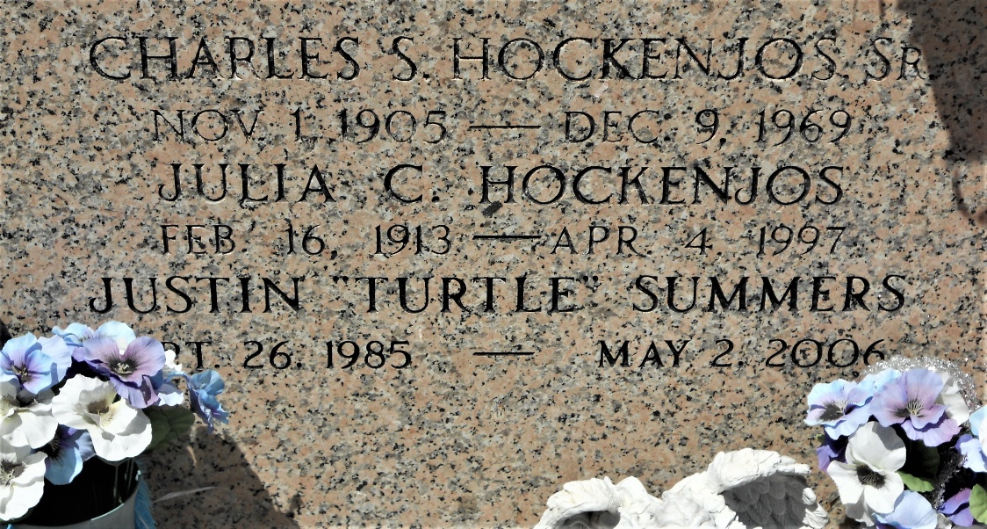
Photo by Team T-Lo

Justin D. (Turtle) Summers on Tuesday, May 2, 2006 at 12 P.M.
Beloved son of Troy and Shirlyn Summers and Wanda and Chris Rowe. Brother of Jennifer Vicknair, Jodie and Taryn Destin Summers. Step brother of Adam and Rachel Rowe. Grandson of Oscar and Jean Vicknair, Pat Vicknair, Bob Berges, Ledaine and Kitty Summers and the late Lois Summers. Age 20, a native and resident of Reserve, LA.
Relatives and friends of the family are invited to attend services. Visitation at Millet-Guidry Funeral Home, 2806 W. Airline Hwy, LaPlace on Friday, May 5, 2006 from 5:00 p.m. to 7:00 p.m. Followed by religious services at the funeral home chapel at 7:00 p.m. Burial to be private at a later date.

The Times-Picayune, New Orleans, Louisiana
Thursday, May 4, 2006, p. 67

