Evelyn (Englade) Sutton
December 21, 1931 – October 21, 2010

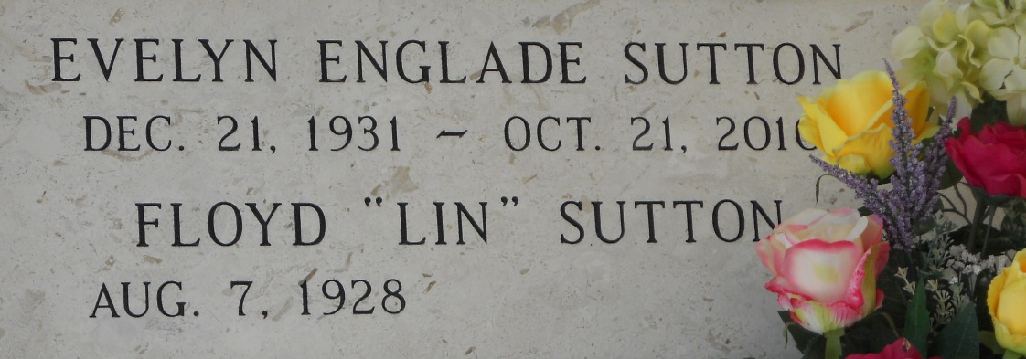
Photo by Team T-Lo

Evelyn Englade Sutton, a native and resident of Reserve, passed away at her home on October 21, 2010.

She is survived by her beloved husband, Floyd J. Sutton Sr.; children, Valerie Sutton, Floyd Sutton Jr. and Jesse Sutton; seven grandchildren, eight great-grandchildren. She was the sister of Betty Englade Pitre, Lynda Sue Englade Smith and the late Jesse O. Englade.

She was preceded in death by parents, Roy J. and Clara K. Englade.

Burial in St. Peter Cemetery, Reserve.

The Times-Picayune, New Orleans, Louisiana
Oct. 22, 2010

