Melanie (Louque) Sutton
April 19, 1949 – August 26, 2012

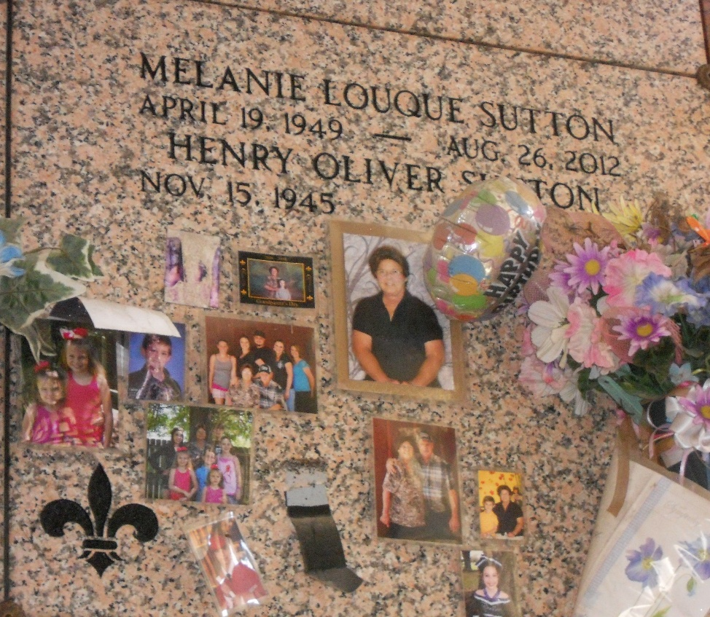
Photo by Team T-Lo

Melanie Louque Sutton passed away at the age of 63 on August 26, 2012 at her residence in Garyville, LA. She was a native and resident of Garyville, LA.
She was the beloved wife of 43 years to Henry Oliver Sutton. She was the loving Mother of Jill Sutton of Garyville, Rhonda Sutton Guidry (Darrin) of Paulina, Angel Sutton, April Sutton, and Boyd Sutton all of Garyville, LA. She was the sister of Jackie Louque Montelius (Robert "Whitebean"), Jerry Louque, Jr., Janine Louque, and Jason Louque; grandmother of Devin Duhon, Kylie Dufrene, Lexi Sutton, Haylie Wilcox, Caden Guidry, and Harlie Trosclair.
She is also survived by her Father and Stepmother, Jerry and Claira Louque. She was preceded in death by her Mother, Doris Louque Vicknair. She was an avid cook, poker-keno player, card player, and gardener.
Relatives and friends of the family are invited to attend the funeral services and visitation at St. Hubert Catholic Church, Garyville, LA on Tuesday, September 4, 2012 from 9:00 a.m. until 10:45 a.m. followed by a Mass of Christian Burial at 11:00 a.m. Burial in St. Peter Church Cemetery, Reserve, LA. ROSE LYNN FUNERAL SERVICES is in charge of the arrangements.

The Times-Picayune, New Orleans, Louisiana
Sep. 3 to Sep. 4, 2012

