Oliver John Sutton Jr.
June 1, 1916 – August 29, 2011

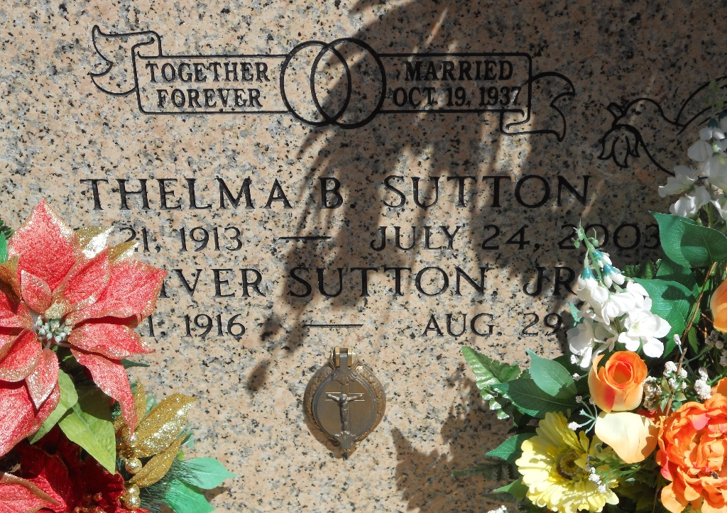
Photo by Team T-Lo

Oliver (June) Sutton Jr. passed away on Monday, August 29, 2011 at 4:50 am.
Beloved husband of the late Thelma Breaud Sutton for 66 years at the time of her death in 2003. Mother of Gloria Miller (Renee), Thelma Spizale, Gertrude Vicknair (John), Theresa Ballard (James), Judy St. Pierre (Richard), Janet LeBoeuf (Todd), Charlotte Kendrick, Henry Sutton (Melanie), Clarence Sutton (Jan) and Charles Sutton (Rena). Also survived by 28 grandchildren, 38 great-grandchildren and 5 great-great-grandchildren.
Son of the late Oliver and Lolita Weber Sutton. Also survived by 5 brothers and 6 sisters. Preceded in death by 1 brother, 1 sister and 1 granddaughter. Age 95. A native and resident of Reserve, LA.
Relatives and friends are invited to attend services. Visitation at St. Peter Catholic Church, Reserve, LA, on Wednesday, August 31, 2011 from 9:00 am to 11:00 am, followed by Mass at 11:00 am. Father Frank Utter Celebrant. Burial in St. Peter Cemetery, Reserve. Arrangements by Millet- Guidry Funeral Home, LaPlace, LA.

The Times-Picayune, New Orleans, Louisiana
Aug. 30, 2011

