Thelma (Breaud) Sutton
August 21, 1913 – July 24, 2003

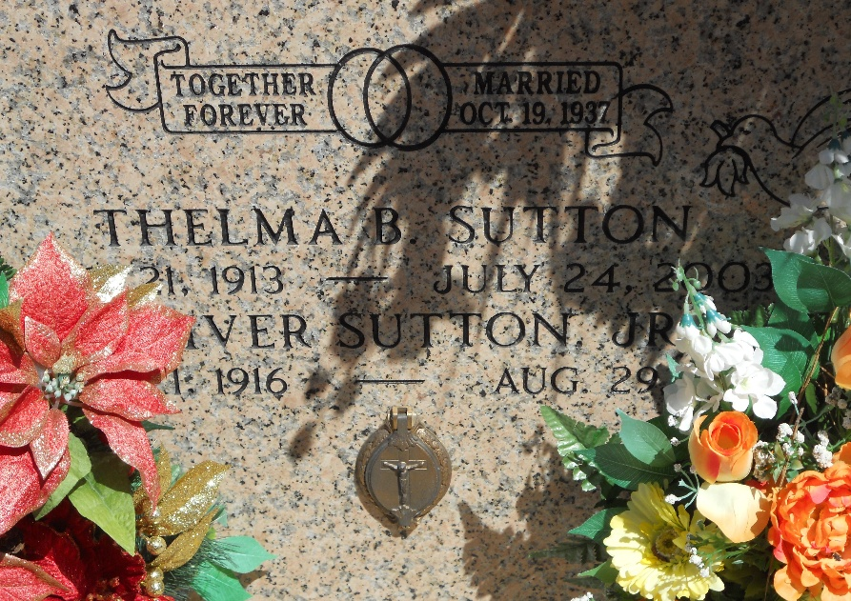
Photo by Team T-Lo

Thelma Breaud Sutton On Thursday, July 24, 2003 At 3:45 Am.
Beloved Wife Of Oliver J. Sutton, Jr. Of 66 Years. Mother And Mother-In-Law Of Gloria And Renee Miller, Thelma Spizale, Gertrude And John Vicknair, Theresa And James Ballard, Judy And Richard St. Pierre, Janet And Todd Leboeuf, Charlottee And Richard Kendrick, Henry And Melanie Sutton, Clarence And Jan Sutton, And Charles And Rena Sutton. Also Survived By 27 Grandchildren And 29 Great Grandchildren.
Preceded In Death By Her Parents, Henry And Martha Leblanc Breaud, 5 Brothers, 1 Granddaughter And 2 Sons-In-Law. Age 89 Years. A Native And Lifelong Resident Of Reserve, La.
Relatives And Friends Of The Family Are Invited To Attend Services. Visitation At St. Peter Catholic Church, Reserve, La On Saturday, July 26, 2003 At 9 Am Until Service At 12 Noon. Burial At St. Peter Church Cemetery. Millet Guidry Funeral Home In Charge Of Arrangements.

The Times-Picayune, New Orleans, Louisiana
July 25, 2003

