John Swafford Sr.
November 8, 1931 – November 9, 2006

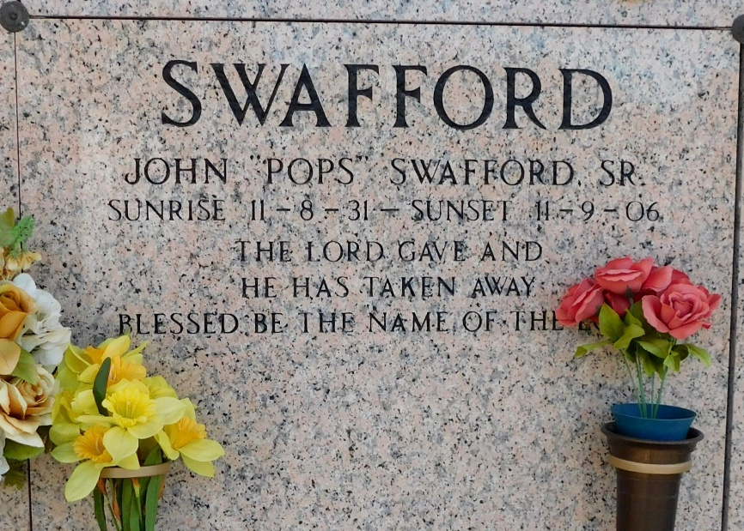
Photo by Mary Agnes Hammett

John Swafford, Sr. on Thursday, November 9, 2006 at River Region Hospice, River Ridge, La.
Son of the late Lucy Hagan and Lonnie Swafford. Father of Arthur Swafford, Alice Marie Swafford, Brenda Swafford, Roberta Miller and William Swafford, all of Oakland, California, Greg of New Orleans, La., Durell of Atlanta, Georgia; John, Jr. and Andre (Sonny) Swafford, both of LaPlace, La. Brother of Willie Swafford of Sorento, La., Annie White of Colfax, La., Charles Swafford of San Diego, California and the late Doretha Chambers of Winnsboro, La. Also survived by 16 grandchildren, 9 great-grandchildren and a host of nieces, nephews, other relatives and friends. Age 75 years. A native of Colfax, La and a resident of LaPlace, La.

The Times-Picayune, New Orleans, Louisiana
November 13, 2006

