Louis Tamburello
1859 – September 27, 1935

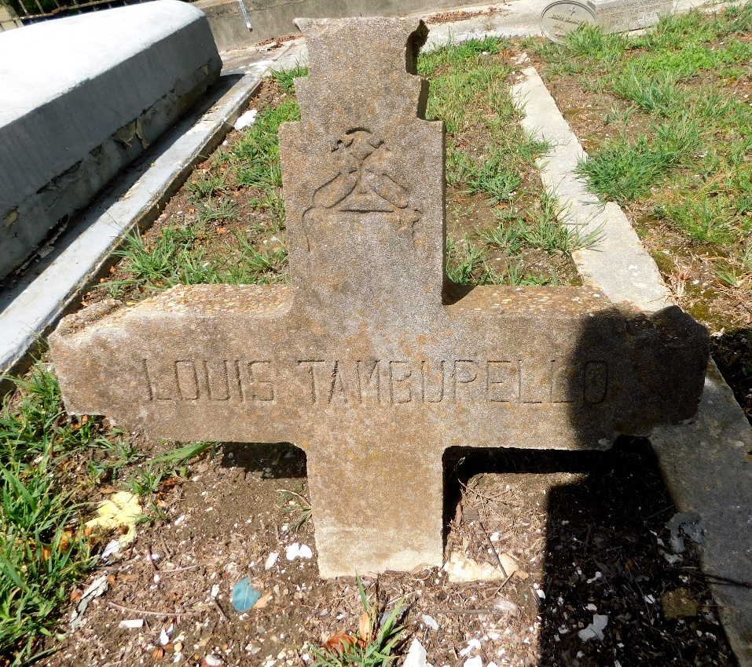
Photo by Mary Agnes Hammett

Tamburello – On Friday, September 27, 1935, Louis Tamburello, father of Mrs. D. Giardina of Birmingham, Ala., brother of Anthony Tamburello of New Orleans, La., aged 76 years, a native of Bisacquino, Italy and a resident of Montz, La., for many years.

Services and interment in Reserve, La., on Saturday afternoon, September 28, 1935, at 2 o’clock. Jules Millet, funeral director. Reserve, La.

The Times-Picayune, New Orleans, Louisiana
Saturday, September 28, 1935, p. 2

