David J. Tamplain
March 30, 1935 – June 5, 2008

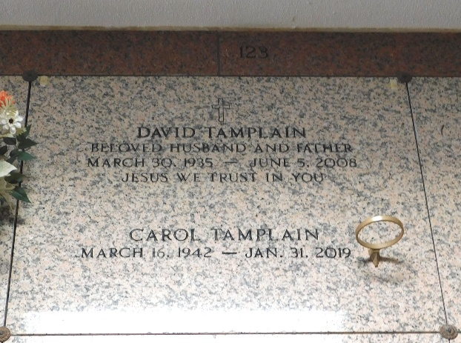
Photo by Mary Agnes Hammett

David J. Tamplain on Thursday, June 5, 2008 at 1:25 p.m. Beloved husband of Carol Tamplain. Father of David and Raymond Tamplain, Cindy Tyner, Karen Taylor, Kathy Howard and the late Sonya Tamplain. Also survived by 11 grandchildren and 4 great-grandchildren.
Son of the late Thomas and Wina Tamplain. Brother of Thomas, Harry, Robert and Lionel Tamplain, Leona Miano, Yvonne Keating, Carolyn Hahn and the late Huey Tamplain. Age 73 years. A native of and a resident of Garyville, LA.
Relatives and friends of the family are invited to attend services. Visitation at MILLET-GUIDRY FUNERAL HOME, 2806 W. Airline Hwy., LaPlace, LA on Sunday, June 8, 2008 from 5:00 p.m. until 9:00 p.m. Religious Services on Monday at St. Hubert Catholic Church, Garyville, LA at 10:00 a.m. Burial in St. Peter Cemetery, Reserve, LA.

The Times-Picayune, New Orleans, Louisiana
June 7, 2008

