Elaine A. (Vilemont) Tamplain
February 9, 1925 – June 2, 2015

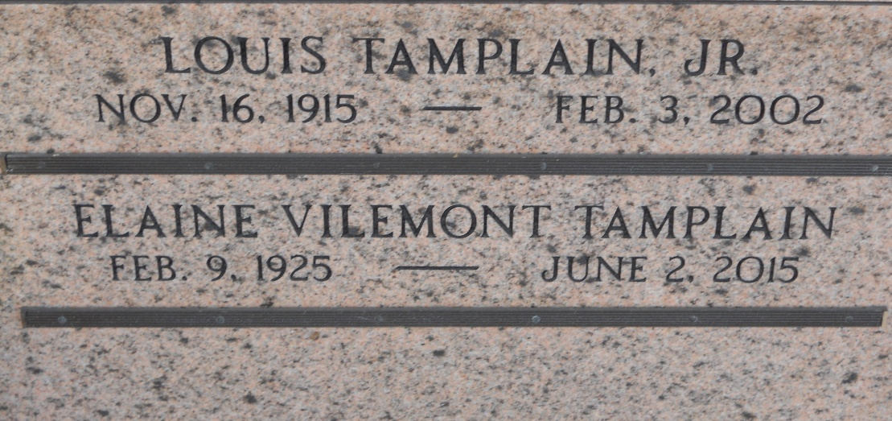
Photo by Team T-Lo

Elaine Vilemont Tamplain of Baton Rouge passed away on June 2, 2015, at Heritage Manor Nursing Home. Born to Louis Vilemont and Adele Perilloux in LaPlace, LA, on Feb 9, 1925.
She was a loving wife, mother and grandmother. Survived by three daughters and their spouses Nadine and Wayne Mixon, Lisa and Mark Rowell, Tobie and Greg King; four grandchildren, Wendy and husband James Lewis, Justin and wife Katie Frick, Evan Capace and Hollyn Capace; and three great grandchildren, Jett and Jax Lewis and Davis Frick.
Preceded in death by husband, Louis Tamplain Jr. and daughter, Nelwyn Britt.
Visitation at Rabenhorst Funeral Home, 825 Government St., Friday, June 5, 2015, from 9:00 am until services at noon in the funeral home chapel. A rosary will be said at 10:00 am. Entombment will follow in St. Peter Cemetery, Reserve, LA.
In lieu of flowers, donations may be made to St Jude Children's Research Hospital or Children's Hospital of Atlanta.

Dignity Memorial

