Huey Charles Tamplain
February 28, 1928 – January 29, 2000

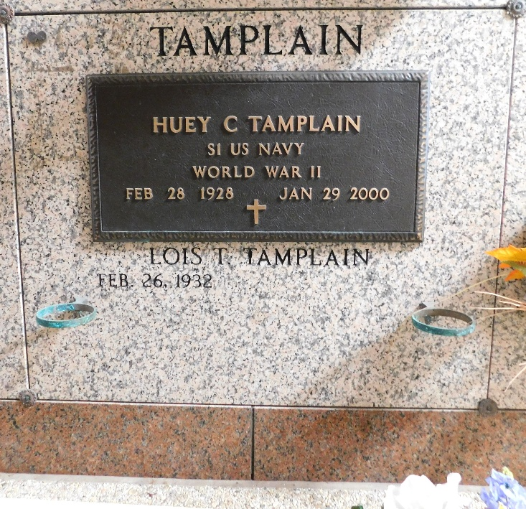
Photo by Mary Agnes Hammett

Huey Charles Tamplain on Saturday, January 29, 2000 at 9:45 PM. Beloved husband of Lois Tregre Tamplain. Father of Eric, Keith, Perry, Dale, Mark, and Bruce Tamplain. Brother of Thomas, Harry, David, Robert, and Lionel Tamplain, Leona Miano, Yvonne Keating and Caroly Hahn and the late Price Tamplain. Also survived by 12 grandchildren, 3 step-grandchildren and 4 great-grandchildren. Age 71 years. A native of Donaldsonville, LA and a resident of Garyville.

Relatives and friends of the family are invited to attend the funeral services at Millet Guidry Funeral Home, 2806 W. Airline Hwy., Reserve, LA on Tuesday, February 1, 2000. Followed by religious services at St. Hubert Catholic Church, Garyville, LA at 10:00 AM. Interment St. Peter Cemetery, Reserve. Friends may call from 5:00 PM until 10:00 PM on Monday and from 8:00 AM until services on Tuesday.

Unknown newspaper clipping
January 31, 2000

