Louis J. Tamplain Jr.
November 16, 1915 – February 3, 2002

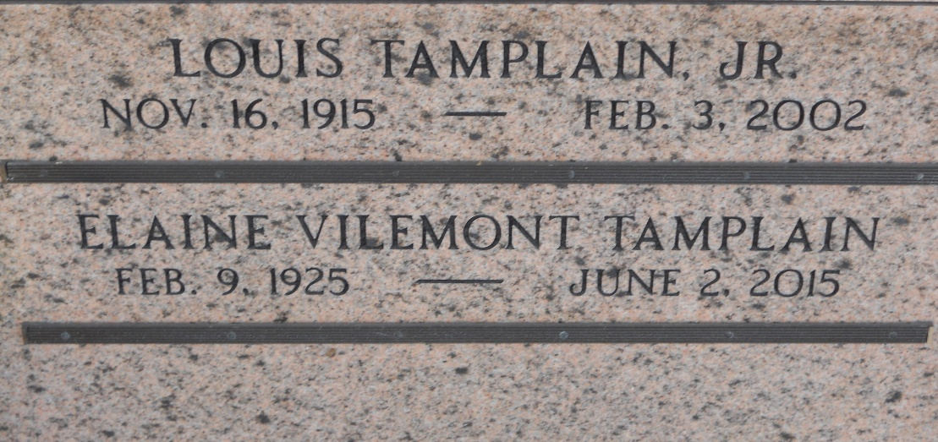
Photo by Team T-Lo

Louis "Sonny" Tamplain Jr, 86, a native of Garyville, Louisiana, and a resident of Baton Rouge, died 3 Feb 2002. He was the husband of Elaine Vilemont Tamplain and the father of Theresa Frick, Lisa Rowell, Tobie Capace and the late Nelwyn Tamplain. He is also survived by four grandchildren.
He was a US Army veteran of World War II and a retired petrochemical contractor.
Services were 5 Feb 2002 in the chapel of Rabenhorst Funeral Home, Baton Rouge, with interment at St. Peter Mausoleum, Reserve, Louisiana.
L'Observateur, LaPlace, Louisiana
11 Feb 2002

