Thomas Wencenslas Tamplain Sr.
July 1, 1897 – April 10, 1966

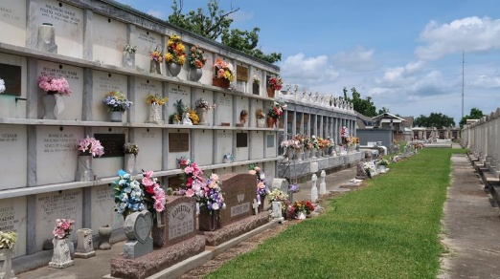

TAMPLAIN – On Sunday, April 10, 1966 at 7 o’clock a.m. Thomas W. Tamplain Sr.; beloved husband of Odette Klibert and by first marriage of the late Wina Robert; father of Thomas Tamplain Jr., of Hahnville, La., Harry Tamplain of Baker, La., David Tamplain of Stanton, Calif., Robert Tamplain and Mrs. Carolyn Hahn of Reserve, La., Mrs. Yvonne Keating of Laplace, La., Huey and Lionel Tamplain and Mrs. Leona Miano of Garyville, La.; step-father of Lawrence Ruiz of Laplace, La., Mrs. Audrey Duke of Reserve, La., James Ruiz of Delaware and Robert and Human Ruiz of Garyville, La.; brother of Mrs. Henrietta Hymel, Mrs. Marie Ockmand and Mrs. Martha Bourgeois; also survived by 32 grandchildren; age 68 years.

Relatives and friends of the family are invited to attend the funeral. Services from Millet Funeral Home, Reserve, La., on Tuesday, April 12, 1966, at 9:30 o’clock a.m., religious services at St. Hubert Church, Garyville, La. at 10 o’clock. Interment in St. Peter Cemetery, Reserve, La. Parlors will open Monday at 2 o’clock p.m.

Unknown newspaper clipping

