Louis C. Tanguis Jr.
December 30, 1921 – February 9, 2008

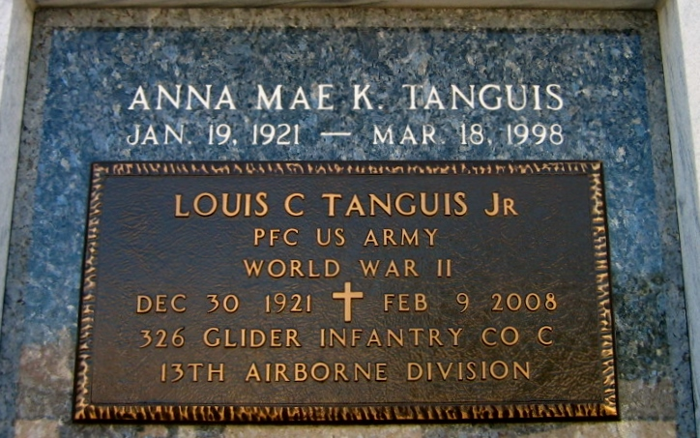
Photo by Bobby

Louis C. "Jesse" Tanguis, Jr., 86, died Saturday, Feb. 9, 2008 at 11:35 AM. The LaPlace resident is survived by daughters, Derra Ferguson and Lana Galino; grandson, Brandon Boudreaux; great-grand daughter, Madison Boudreaux.
Preceded in death by wife, Anna Mae K. Tanguis; parents, Louis and Eugenia Dupepe Tanguis; sisters, Amelie Vessier and Marjorie Tanguis.
Religious Services were Tuesday, Feb. 12, 2008 at Millet-Guidry Funeral Home Chapel. Burial followed in St. Peter Cemetery in Reserve.
L'Observateur, LaPlace, Louisiana
Wednesday, February 20, 2008

