Theresa Marie (Schexnayder)
December 30, 1921 – February 9, 2008
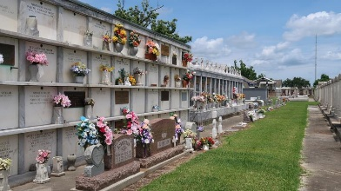

Theresa Schexnayder Triche Tanguis passed away peacefully with her family by her side and entered into eternal rest on Friday, September 30, 2016. She was 91 years old and a native and resident of Reserve and Twin Oaks Nursing Home in LaPlace.
Theresa was the beloved wife of the late Roland "BabyDoll" Triche and the late Eugene (EJ) Tanguis. She was the daughter of the late Lelia Waguespack and Ferducie Schexnayder, and sister of Eleanore Hofmann, Alma Martin and the late Marie Schexnayder, Sophie Stein Hotard, Lelia Boe Kelly, and Joseph Schexnayder. She was the beloved mother of Theresa Triche Aubert (Roy) and Joy Triche Millet (E.P.). Grandmother of Kent Aubert and Ryan Aubert (Suzy), Steven Millet (Crystal), Kevin Millet (Shannon), and Curtis Millet. Great grandmother of Ashlyn, Austin, Kayla, Lauren, and Hailey Millet, Siena and Evangeline (Evie) Aubert. She is also survived by many nieces and nephews.
The family would like to extend their heartfelt thanks to the staff of Twin Oaks Nursing Home and Harmony Hospice for their loving care. Special thanks with love to Judy (CNA) "Our Special Sister", who loved and cared for our mother like her own for 9 years. Loving thanks to our mother's "Special Angel" who watched over her with love.
Relatives and friends are invited to attend the Funeral Mass at 11 a.m. on Thursday, October 6, 2016 at St. Peter Catholic Church, 1150 Highway 44 in Reserve. Visitation is from 9 to 11 a.m. at the church. Interment is in St. Peter Cemetery. Arrangements are being handled by Millet-Guidry Funeral Home. In lieu of flowers, masses would be appreciated.

The New Orleans Advocate, Louisiana
Oct. 2 to Oct. 6, 2016

