Elaine (Duhon) Taranto
September 21, 1919 – August 24, 2010
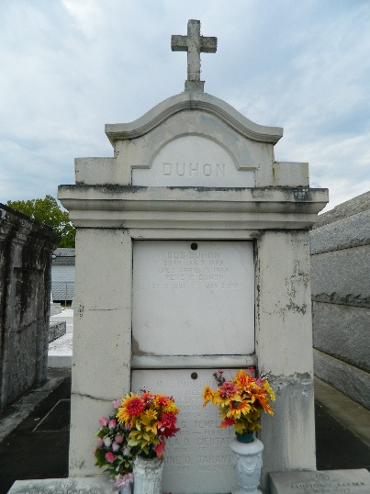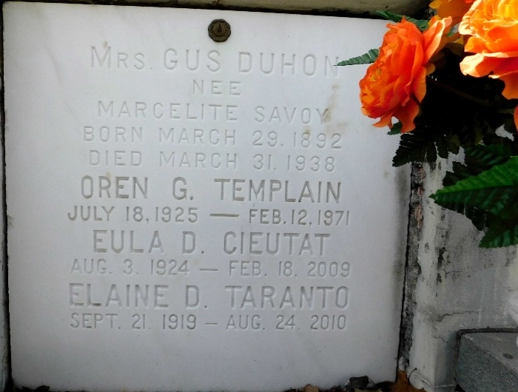
Photo by Mary Agnes Hammett

Elaine Duhon Aubert Barber Taranto, 90, a devoted wife and mother, passed away Tuesday, Aug. 24, 2010, at Heritage Manor Nursing Home in Baton Rouge. She was a native of Donaldsonville and resident of Baton Rouge for 38 years.
There was a visitation at Ourso Funeral Home in Gonzales on Thursday, Aug. 26, from 5 p.m. to 9 p.m. Visitation will resume at St. John the Evangelist Catholic Church, Prairieville, Friday, Aug. 27, from 10 a.m. until a Mass of Christian Burial at 11 a.m., with the Rev. Eric Gyan, celebrant. Entombment in St. Peter's Catholic Church Cemetery, Reserve.
Survived by her husband, Vernon A. Taranto Sr.; two children and their spouses, Paul and Michele Aubert, of Prairieville, and Angelique and Bill McIntyre, of Hammond; and two grandchildren, Rachel Aubert Devall and her husband, Jason, and Melissa Aubert Decker. She was expecting the arrival of her first great-grandchild in March 2011. She is also survived by a sister, Ennie Beadle, of Reserve; extended family, Bud and Sharon Barber, of Picayune, Miss., Genie and Jimmy Bruno, of Baton Rouge, John and Cheryl Taranto, of Las Vegas, Paul and Darlene Taranto, of Prairieville, Vernon A. Jr. and Mary Ann Taranto, of St. Petersburg, Fla., and Laura and Horace Shows, of Prairieville; and many step grandchildren, great-grandchildren, nieces and nephews.
Preceded in death by her parents, Gus Duhon and Marcelitte Savoie Duhon; sister, Eula Cieutat; brothers, Kearney, Elwood and Rene Duhon; first husband, Leo Joseph Aubert; and second husband, Clinton C. Barber.
She was cafeteria manager at St. Peter's School, Reserve, and dietitian with the LSU cafeteria system. She was an avid cook who was featured in The Advocate FOOD section. She was very active in her church community and a devout Catholic. In lieu of flowers, memorial donations may be made to Alzheimer's Services of the Capital Area.

The Advocate, Baton Rouge, Louisiana
August 26-27, 2010

