Rebecca Therese (Labat) Tassara
July 17, 1979 – August 15, 2017

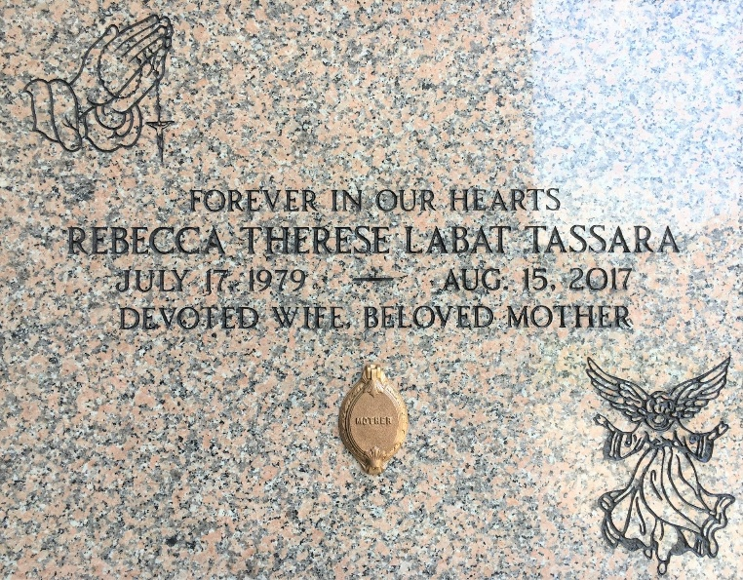
Photo by Team T-Lo

Rebecca Therese Labat Tassara passed peacefully on Tuesday, August 15, 2017 after a brave fight with cancer, surrounded by her family and those closest to her. She was a wonderful wife, mother, sister, friend and colleague. Rebecca fought her breast cancer battle courageously to her last breath after exhausting all medical options. She had an unbreakable faith and a personal relationship with God.
Rebecca enjoyed spending time with Michael and their children and would go out of her way to make them happy. She loved to decorate and entertain with family and friends. She was highly regarded in her professional career. Rebecca was a giving, loving, thoughtful person and will be sadly missed by all.
Beloved wife of Michael Anthony Tassara, Jr. Loving mother of Cadence Michelle Tassara, Camryn Alexandra Tassara, Cole Michael Tassara and Caleb Joseph Tassara. Daughter of Trudy Haydel Labat and Terry Paul Labat. Sister of Joseph Labat (Rebecca), Rachel Meyers (Justin), Jude Labat (Renee), Elizabeth Kurian (Minoj), Stacie Labat, Louis Labat, and Philomena Hunt (Scott) and the late Marie Jeanne Labat. Granddaughter of Arnold Labat, Geraldine Bleakley Labat, Grace Bodin Haydel and the late Bolden Haydel. Daughter-in-law of Elaine Boe Tassara and Michael Anthony Tassara, Sr. Sister-in-law of Mellissa Tassara, Matthew Tassara and the late Michelle Tassara. Also survived by numerous aunts, uncles nieces and nephews.
Relatives and friends are invited to attend the visitation at Millet-Guidry Funeral Home, 2806 W. Airline Hwy, LaPlace, LA on Friday, August 18, 2017 from 11:00 a.m. to 1:00 p.m. followed by the Funeral Mass at St. Peter Catholic Church, 1550 Hwy 44, Reserve, LA at 1:30 p.m. Interment in St. Peter Cemetery.

The New Orleans Advocate, Louisiana
August 16-18, 2017

